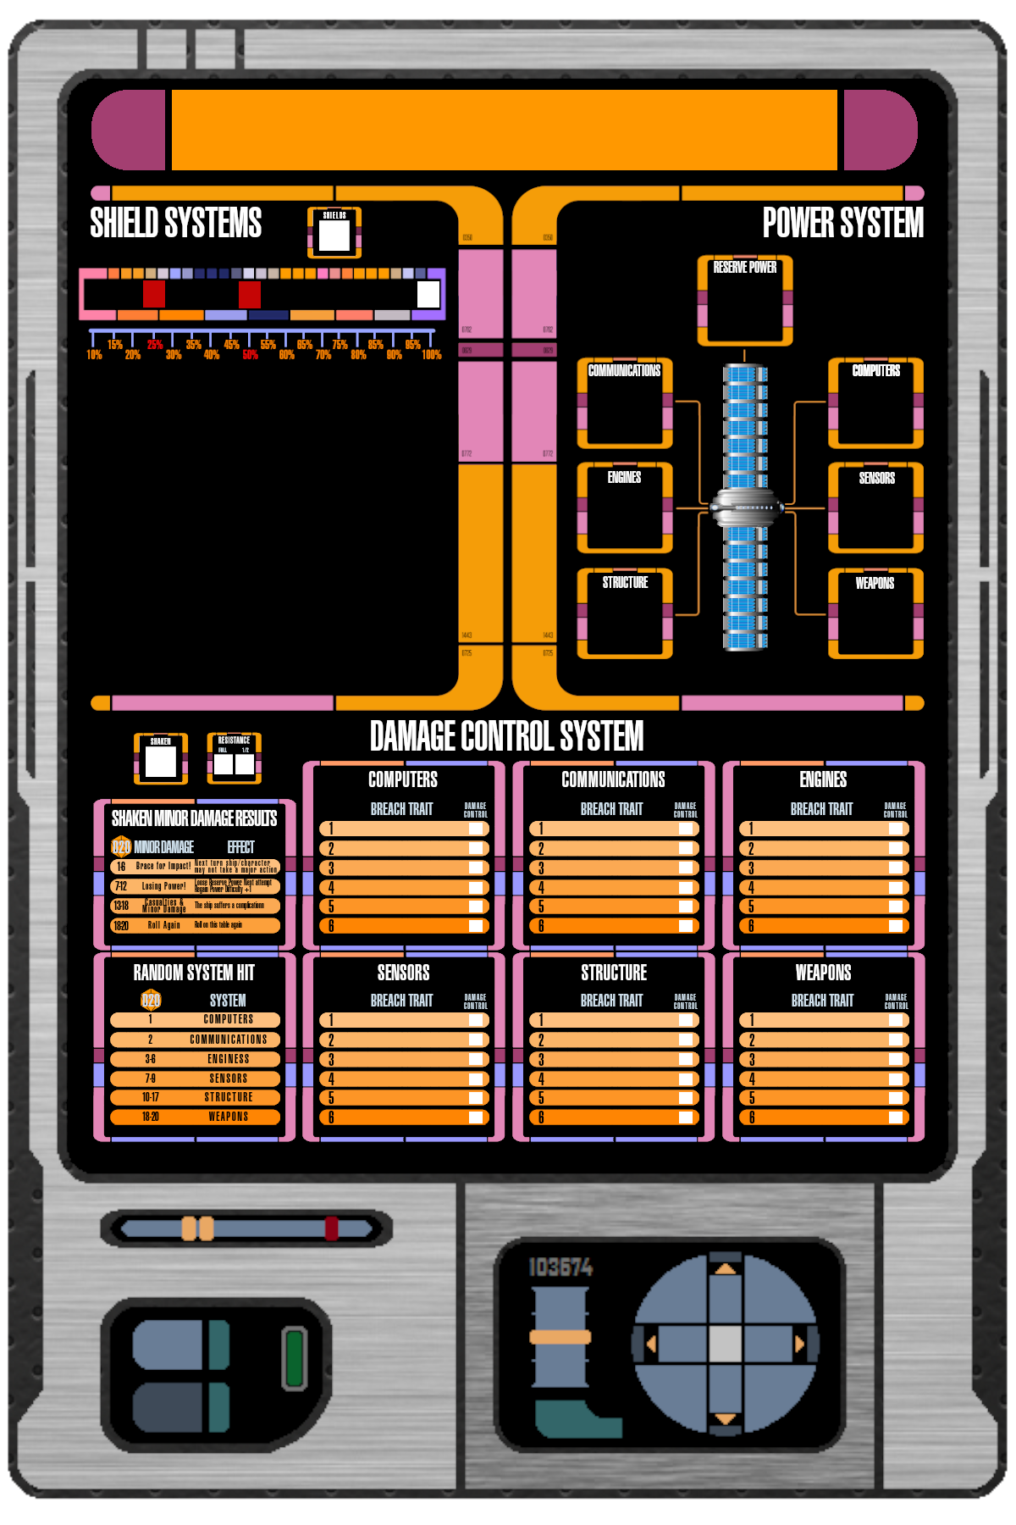

STARSHIP NAME



Reserve Power Tokens

 |  |  |  |  | 
 |  |  |  |  | 
 |  |  |  |  | 

