Sarell

Expanse

Campaign Guide

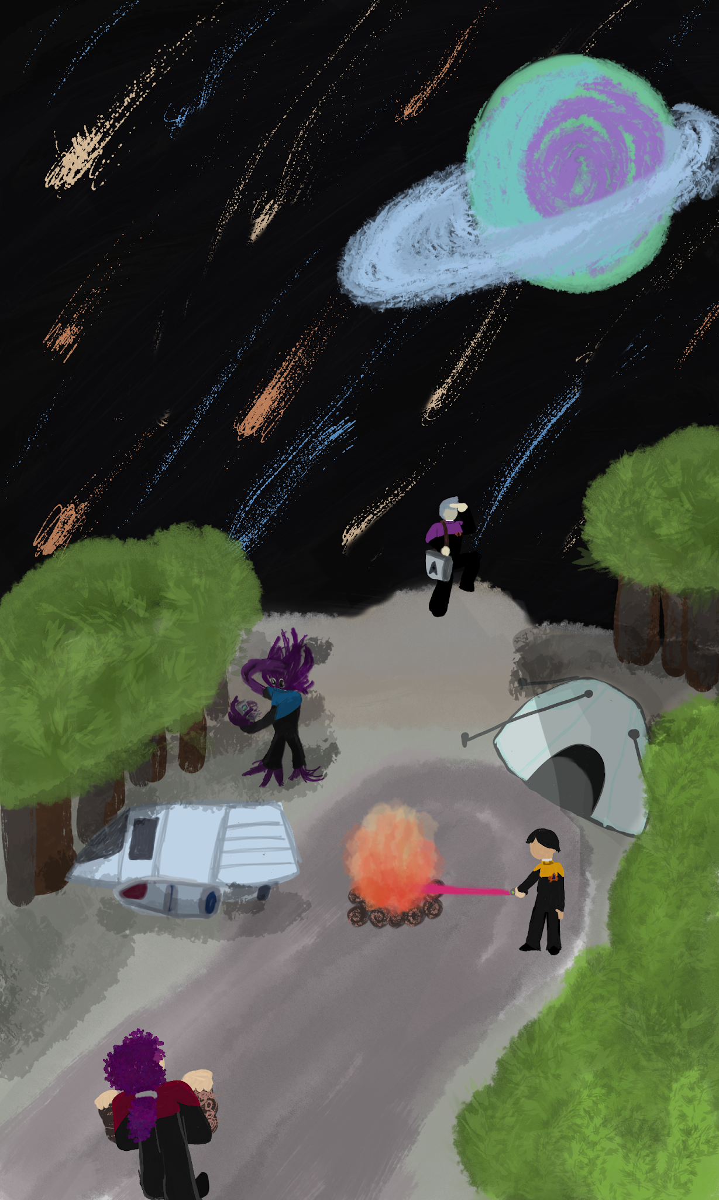
a Star Trek Adventures 2e-Compatible Expansion
by Samuel Sarette

This campaign book is a fan work.

Everyone is free to use, tweak, copy, and reference the materials within.

Only the portions of this work which are wholly original (many characters, planets, stories, etc) are © 2026 Samuel Sarette and CC0 licensed. Derivative or directly-referenced intellectual property related to Star Trek or Star Trek Adventures is not owned in any way by Samuel Sarette.

The “Star Trek Adventures” table-top RPG is a product of Modiphius Entertainment Ltd.

TM & © 2026 CBS Studios Inc. © 2026 Paramount Pictures Corp. STAR TREK and related marks and logos are trademarks of CBS Studios Inc. All Rights Reserved.

Official Star Trek Adventure products which are referenced in this book in order of how necessary they are as a prerequisite read/purchase:
- STA 2e Core Rulebook
- STA 2e Game Toolkit
- STA 2e Allies and Adversaries Sourcebook
- STA 2e Exploration Guide
- STA 2e Species Sourcebook
- STA 2e Technical Manual

Forward 5
Introduction 6
The Sarell Expanse 6
Stellar Cartography 7
Factions 8
Summary of Events 10
Starfleet’s Mission 11
Supplemental Game Mechanics 12
Career Path Options 12
New Career Events 13
New Environment Options 15
Character Options 19
Starbase 418 28
Starship Options 29
Shuttlecraft 35
Expanse Technology and Gear 36
New Comm Badges 36
Protective Gear 37
Weapons 38
U.S.S. Frost NCC-92135 41
Captain Clemente J. Jackson 42
Alden Galarus A.I.H 43
Commander Tove Marla 44
Lt. Commander Iria 45
Commander Teagan Sh'Aielenza 46
Commander Christopher Ellis 47
Lieutenant Tau 48
Lieutenant Scylla 49
Fenchurch Olive Petra of the Dawn Glow 50
Story 51
Mission 1: Welcome to the Expanse 52
Mission 2: The Aurora Caverns 53
Mission 3a: Spectacular Shutdown 54
Mission 3b: Shadows of the Past 55
Mission 4: The Ghost Town 56
Mission 5a: A Tol Tale 56
Mission 5b: Two Roads Diverged 57
Mission 5c: Shore Leaving 59
Mission 6: Statues in the Dark 60
Mission 7: An Echo Too Many 61
Mission 8a: The Grahk Squad 62
Mission 8b: The Trianum Protectorate 63
Mission 8c: Small-Colony Troubles 64
Finale Mission: The Dyson Vine 65
NPCs 67
Starfleet 68
Temporal Agents 70
Tol 71
Queenless Borg of Hexeract 74
Various Adventure NPCs 75
Dyson Vine Cult 78
Starships 81
Temporal Agents 81
Tol 82
Queenless Borg of Hexeract 84
Various Adventure NPCs 86
Dyson Vine Cult 88
Roll Tables 90
Selecting a Mission Location 91
Additional Mission Theme Suggestions 92
Adapting the Campaign 93
22nd Century 93
23rd Century 94
29th Century 94
32nd Century 95
Klingon 96
Romulan 96
Ferengi 97

Forward
I started this project as another side project where I could place the creative energies from learning Blender and being a game master for a prewritten module, which I was very worried about — starting a Shackleton campaign as someone who always ran their own written modules best. I'm still writing plenty for that campaign, so silly me.

When I began, only the core rulebook of the second edition was out. As more books came, I realized I needed to be referencing them to avoid overlap with the officially licensed materials. This was the first motivation to hurry up and “publish” this fan content to the world.

I want to finish this while I have the motivation to do so.

The second motivator has been a strengthening spite for generative AI being used instead of human creativity. While I initially tried to see how it could help me create this; I ended up throwing any of it away and stepping up creatively instead. Rest assured this one's from me to you.

The replicator just isn't going to top Grandpa Sisko’s jambalaya.

This is a book of ideas, threads, tools, and a general story to be used as the starting point for game masters to create something brand new for their tables. It is not a paint-by-numbers follow-along, you’ll have to do a little work on top of all the things I’ve made for you. You can find Sarell Expanse 3D print files online and 2d art options in my very own character creator tool online, hopefully helping you to create your crew and NPCs.

I love this game, Star Trek and the indomitable human spirit.
Have fun and prosper, y’all.

Introduction
The dawn of the 25th century is an uncertain time, a time for re-assessing tactics and reputations. Starfleet is leaving an era of constant threat, thinly-stretched resources, and receding to safety. Now ready to get back out there, move outward and onward, technology of the period is built with a goal of returning to the optimism of the past, but without the naive vulnerability that led us deep into trouble with the Cardassians, Borg and Dominion.

While medicine is still an integral part of scientific endeavours, the fleet has seen the need to differentiate healing from analyst staff during emergencies — which in some periods was denoted by white uniforms or optional coats — a bold new purple uniform colored future for medical officers has arrived.

Incursions into the timeline by agents of a time war or those in future coming back to clean up timeline changes both leave the Department of Temporal Investigations with exhaustion and a growing staffing need. Temporal defenses are coming to shield us from violations of the temporal prime directive.

On this set stage, we discover a new region of space unexplored, yet nearby
— The Sarell Expanse.

The Sarell Expanse
The cultures of the newly-discovered expanse are unique and varied. We only have slight glimpses of what we might find out there. A mixture of naturalistic and technological societies seem to inhabit the region, a microcosm of the greater galaxy and its quadrants.

Stellar Cartography
The Sarell Expanse is on the border of Beta and Delta Quadrants, a good 50 lightyears, just under a month’s travel at regulation Warp Factor 7, from Starbase 185 until you reach the relocated and refit Starbase 418.
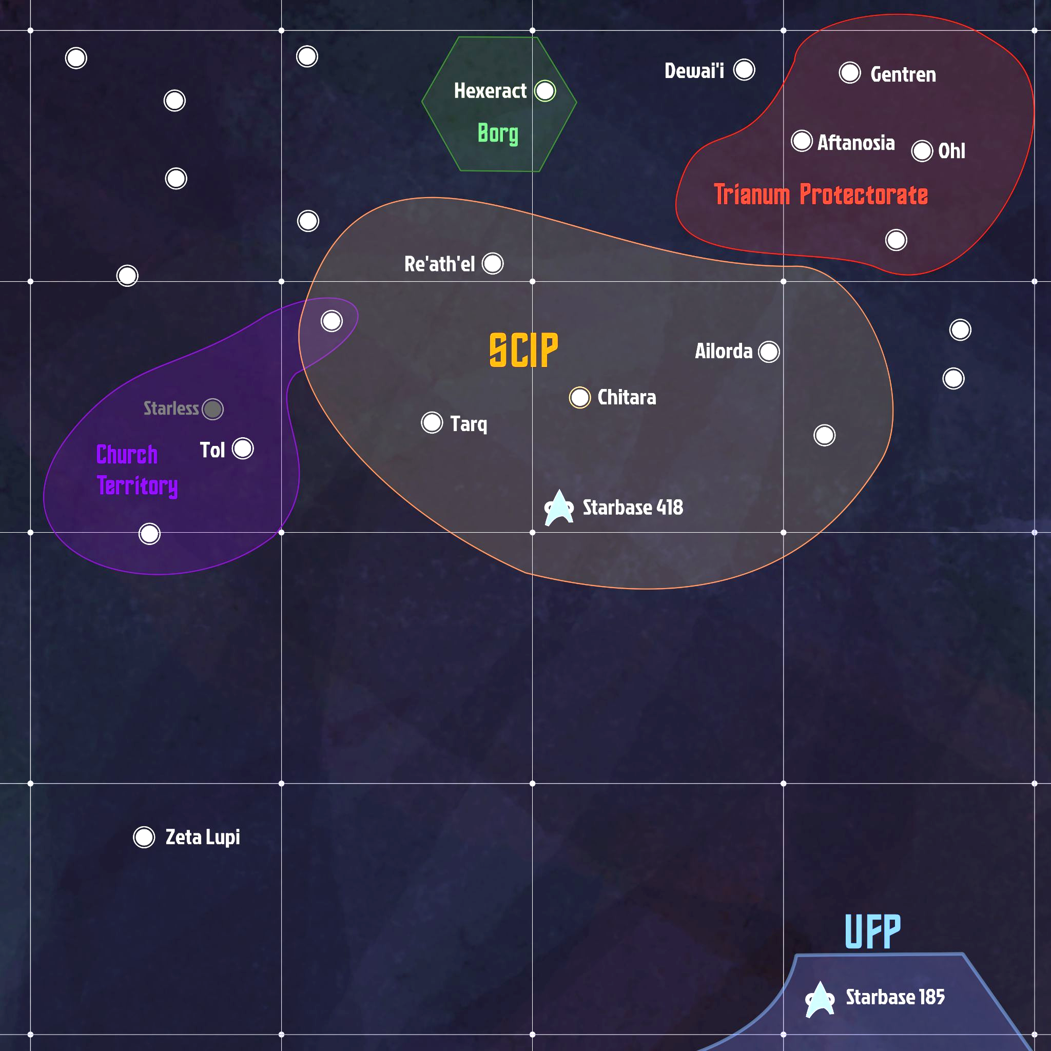

Factions

Sarellan Confederation of Independent Planets
The SCIP: a polity comprising mainly of four worlds from four systems: Chitara, Ailorda, Re’ath’el, and Tarq. These planets’ citizens may freely trade and travel between member worlds, like a smaller version of our own United Federation of Planets. Their planets are plentiful, their cultures are vibrant, and they are excited to open diplomatic relations with the Federation and welcome Starfleet scientific and exploratory missions.

Theirs is also a moneyless society, where citizens’ quality of life is determined by their social connections and reputation. Working hard to better the community and earning respect by caring and making good on promises are, like in the Federation, the “currency”. Trade with external partners is typically done via trade agreements, exchange not payment.

Trianum Protectorate
A diplomatic and defense pact was signed centuries ago that the three systems — Gentren, Aftanosia and Ohl — would defend their space and financial interests.

Ancient Ferengi legends speak of a land of suckers, and the cultures of the protectorate have legends speaking of aliens who came as pirates with incredible eavesdropping powers. You do the (financial) math.

Remnants of an ancient wormhole to the western Alpha Quadrant are present and have left behind a millenia of spacetime eddies, mysterious gravity wells, and regions to the northwest that have a “scarred” subspace, making warp travel dangerous.

Church of Ahl the Orgsordent
A religious movement and organization that began as dominant theology in the Tol system, but has devout followers all across the Expanse.

Their core belief is that a deity known as Ahl, described as being “orgsordent”, protects all his followers from the horrors of Semerhossa, a creation entity that is an unthinking primal force of nature. That life and death are both thrust upon us unwillingly.

The newer dogma of the Ahlen Church in regions like the S.C.I.P. is that Ahl represents our desire to create artificial items and heal our fellows to push off death.

The closer to Tol Major one is, the more the older dogma is practiced: that constant praise of, deference to, and ritual sacrifices to Ahl is necessary to appease the Orgsordent. That plant life is evil, even when begrudgingly necessary to live.

The Theocratic Tol Major has harbored xenophobia to many species of the region and their people have practiced both war and terrorism towards the Chlomorii in particular.

The Queenless Borg
An offshoot of Borg that live harmoniously in the region. They are not often seen leaving their home system, Hexaract.

They are far more inscrutable than Borg normally are, in that they never choose a representative to deal with outsiders, they do not use nanoprobes for assimilation, and do not have a hierarchy of any kind.

Summary of Events

2404
- Federation Colonists push to the galactic northwest.

2405
- Contact between the colonists of Roanoke settlement and Starbase 185 was lost completely.
- Andorian Shipyards begin drafting designs for a new series of fleet designs.

2406
- A special envoy led by Admiral T'Vel discovers an entire region of populated planets while searching for the colony, the Sarell Expanse - a name meaning “stellar neighborhood” by locals.
- Denizens of the expanse haven’t made exhaustive scientific and exploratory missions of the region to share, but welcome us to do so.
- Coordinated exploration campaign drafted,
Andorian shipyards contracted to make their designs work for this effort,
and Starfleet makes preparations.
- Starbase 418 reduced to a skeleton crew, moved to Earth for massive refits.
2407
- A newly-rennovated Starbase 418 successfully towed to the edge of the Sarell Expanse, begins staffing with Starfleet and some local (S.C.I.P.) personnel.
- The Sarell Expanse Mission begins with new ships, new uniforms, and a new region of space to explore full of new friends, stellar phenomena, and biomes.

Starfleet’s Mission
It is of the utmost importance that we discover what happened to our federation colonists, introduce ourselves to new neighbors, and explore again.

Sarell Mission Uniforms
Harkening back to various prior uniforms, the starfleet uniform designed for crew assigned to the expanse have 23rd century-inspired structured collars, to encourage a level of decorum amongst those representing us to new peoples, but otherwise keep the comfort of late 24th century uniforms that have proven popular.

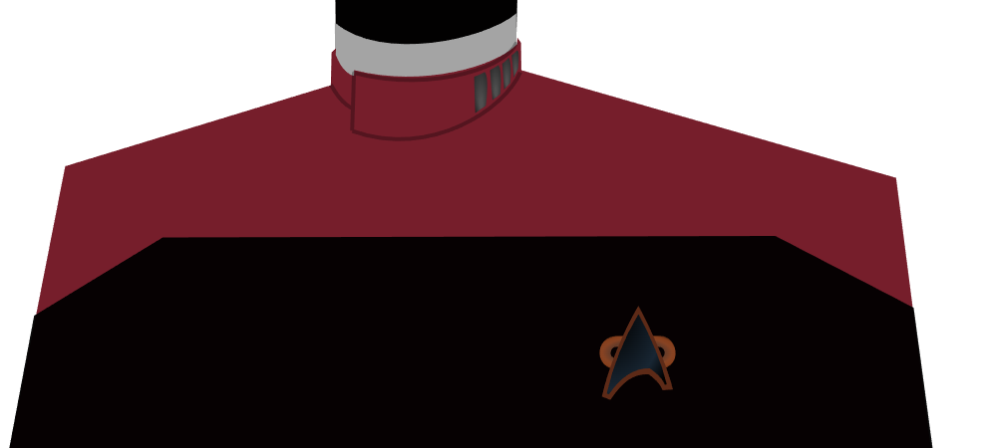 | 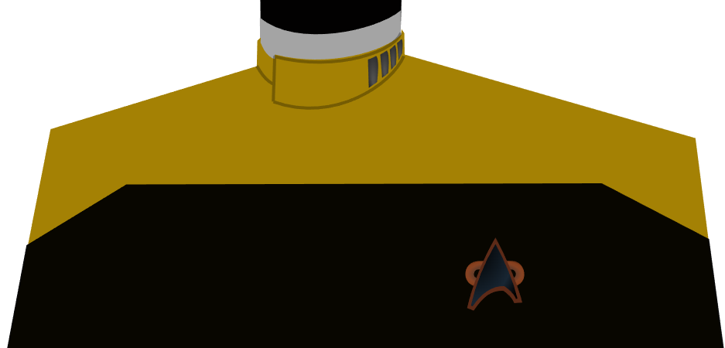 | 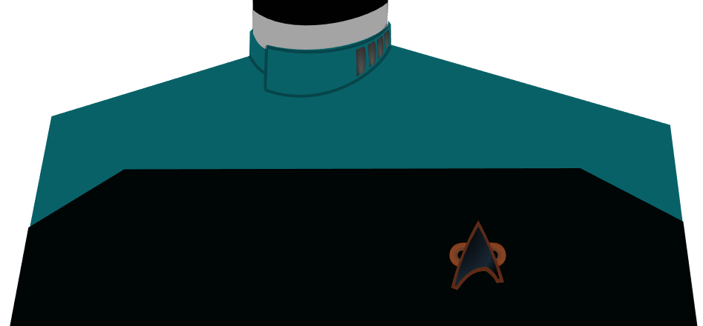
Command | Ops / Eng. / Security | Science
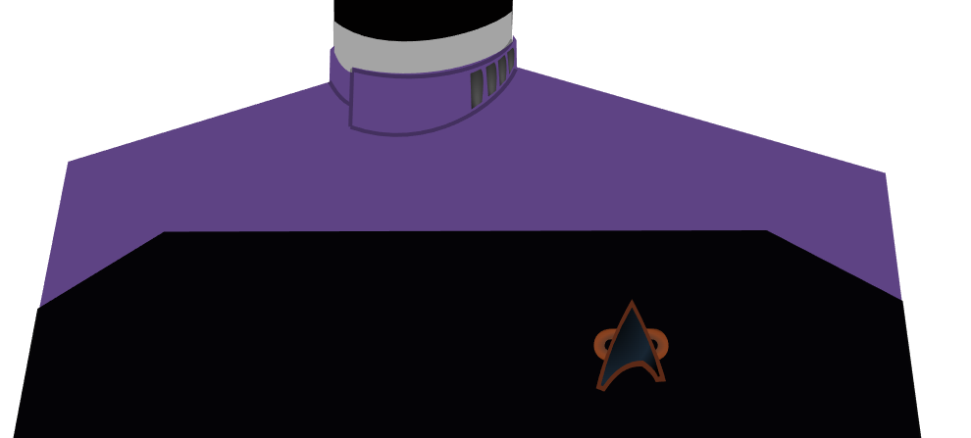 | 
Medical | Intelligence

Inverse Coloration Variant
Captains who prefer a more colorful crew, similar to the mid-24th century uniforms, can opt for this variant.
 |  | 
Command | Ops / Eng. / Security | Science
 | 
Medical | Intelligence

Supplemental Game Mechanics

Career Path Options
Key career paths will be the Starfleet, Diplomatic Corps, and Civilian Scientist from the 2e Core Rulebook. Additionally, this guide provides another option: the Starfleet Corps of Engineers.

Starfleet Corps of Engineers
These are the brilliant people from all corners of the federation that come together to craft the bold and dynamic starships in use by Starfleet.

On screen, this group is seen exclusively on starship dedication plaques.

In the Sarell Expanse, the Andorian shipyards state-of-the-art designs are only just being field-proven, so you may find a member of the SCE on your ship to understand and adapt their designs in use, alongside your regular engineering staff.

Trait: Your character gains the trait SCE Engineer.

Value: You gain a single value, which should reflect your character’s beliefs developed during their career in the Corps, or that led them to join it. Examples:
- Building the future is our most important job today.
- Provide what people don’t know they want.
- We can always start from scratch when the situation changes.

Attributes: You gain three points, to divide across two or three attributes. At least one of the attributes you increase must be Control or Reason.

Departments: Increase your Engineering by 2 and another 2 points divided across either Command, Security, or Science.

Focuses: You gain a focus in Starship Design. Select two other focuses. Examples include anything from the 2e Core Rulebook page 94’s Engineering column.

Talent: Select a single talent.

D20 | Career Event
1–3 | Worked for another Federation Culture
4–6 | Visited a Hidden Region of Space
7–9 | Earned the Respect of a Hostile
10–12 | Found a Peaceful Alternative to Hostilities
13–15 | Made Telepathic Contact
16–18 | Led a Vital R&D Project
19–20 | Select from another book or roll again

New Career Events
These events are related to the mission ahead in the Expanse, or the events that led up to this moment in Federation culture and history.

Worked for another Federation Culture
Too many other Federation citizens miss out on the opportunity that unrestricted migration between member states offers. You spent time as a professional on a world other than your homeworld.
- Attribute: +1 Daring
- Department: +1 any department
- Focus Suggestions: Xenolinguistics, Customs of X (culture), Lingo for X (culture and/or industry)

Visited a Hidden Region of Space
You found yourself on a mission involving folded spaces, pocket dimensions, other planes of existence, or stable temporal bridges. You did well enough to get back home again.

- Attribute: +1 Daring
- Department: +1 Conn
- Focus Suggestions: Survival, Exotic Physics, Subspace

Earned the Respect of a Hostile
We fight when we must, but the first step towards peace is mutual respect. Your valor caused an enemy to call a temporary truce or you found yourselves stranded and didn't leave them behind.

- Attribute: +1 Insight
- Department: +1 Command
- Focus Suggestions: Bluffing, Persistence, Emergency Medicine

Found a Peaceful Alternative to Hostilities
When hostilities seem unavoidable, the best of Starfleet try even harder to find peace. You were successful against impossible odds or under fire.

- Attribute: +1 Reason
- Department: +1 Security
- Focus Suggestions: Survival, Persistence, Negotiations

Made Telepathic Contact
Explorers sometimes find that connecting to others happens from mind to mind. Whether a shared dream connection, mind meld, or temporary hive assimilation, you spoke with the unspeakable and learned or negotiated.

- Attribute: +1 Insight or Reason
- Department: +1 Science
- Focus Suggestions: Xenobiology, Neuroscience, Exotic Communications

Led a Vital R&D Project
A team needs direction, protection from the turmoil of project management, and a clear-headed voice of authority when the inevitable social situation calls for it. You were the cheerleader, the pioneer in design, and supporter of your team that created something amazing.

- Attribute: +1 Command
- Department: +1 any department
- Focus Suggestions: Social Navigation, Persuasion, Modeling & Design

New Environment Options
When creating characters who grew up in the Sarell Expanse, you may choose one of these worlds or regions.

Chitara IV
The fourth planet in the Chitara system, is this planet populated mostly at the poles by the Chita-Gorvan. Lush jungles make way for rocky mountain ranges and a great desert across the equator.

The Chita-Gorvans have built massive cities stretching up into the sky with massive skyscrapers and down into the mountains deep with subterranean nightlife where the people party like nowhere else.

Value
When selecting this environment for a character, write a value representing how growing up here affects them, adopting, adapting, or rejecting the culture or place.
- There is always another project or adventure waiting for those who look for one.
- Go further: you won’t understand from only a first impression.

Attribute
Increase Insight or Fitness by 1.

Attribute
Increase Conn or Engineering by 1.

Chitara V
Where the Chita-Delvan are from.
Perfectly temperate with large swaths of agricultural fields and many small towns dotting along the way. Beautiful forests with tall trees, small brush, you name it - the diversity of flora is incredible, two-hundred thousand species of tree alone!
The cities and towns are a paradise of amphitheaters, museums, and coffee shops where the people discuss and create.

Value
When selecting this environment for a character, write a value representing how growing up here affects them, adopting, adapting, or rejecting the culture or place.
- Connection sometimes takes storytelling.
- You have to at least try to understand others, even if it’s hard.

Attribute
Increase Insight or Presence by 1.

Attribute
Increase Command or Medicine by 1.

Tarq Major
This is the larger class-M planet in the system, protected by a nearby gas giant. It’s on the less-habitable end, towards class-N, constant storms rage along the surface, particularly around the poles, but the geology of the planet uniquely created billions of interconnected underground chambers full of minerals, water, and teeming with life.
The Yil’s civilization has thrived here just below the surface. Its largest metropolis is Tuntagrunda, which has hundreds of miles of public transit tunnels.

Value
When selecting this environment for a character, write a value representing how growing up here affects them, adopting, adapting, or rejecting the culture or place.
- We find ways to thrive even in the harshest of places.
- The stars are a privilege not to be taken for granted.

Attribute
Increase Control or Reason by 1.

Attribute
Increase Conn or Engineering by 1.

Re’ath’el Major
Technically, most residents live on Re’ath’el Major’s moons and the Motherplant interweaving sinews between. A rare sight in all the galaxy, maybe even the universe, a whole planet and moon system connected by fauna. Within the motherplant, there are oases and an atmosphere, providing an extremely unique experience for all who visit. The Chlomorii have effectively grown a civilization by sheer numbers alone. They thrive within the nourishing Motherplant which brings nutrients from the planet below. A map of the place has been provided by the Chita-Gorvan who manage trade and tourism for the Chlomorii - as they can’t be too bothered with it. As long as the Chita-Gorvan keep doing a good job, they’re happy not to lift a finger.

Value
When selecting this environment for a character, write a value representing how growing up here affects them, adopting, adapting, or rejecting the culture or place.
- Taking time out to recenter and relax when you’re in over your head.
- You can make an enemy or rival a partner by going into business with them.

Attribute
Increase Presence by 1.

Attribute
Increase Medicine by 1.

Minor S.C.I.P. World
There are many planets who have joined this local intergalactic governing body, either for protection, community, or to improve their access to resources. While there are many long established planets with their own populations and many colonies of folks from other S.C.I.P. planets among these.

Value
When selecting this environment for a character, write a value representing how growing up here affects them, adopting, adapting, or rejecting the culture or place.
- Even in the remotest places; find strength in your connections.
- Take the greatest of pride in being a good neighbor.

Attribute
Increase Daring or Presence by 1.

Attribute
Increase Conn or Security by 1.

Tol II (& Ahlen Church Territory)
In the shining heart of Church territory. The followers of Ahl the Orgsendent live on a beautiful lush planet. Waves crash against an abundance of fjords, lush ocean cliffs, green mountains, and cold sandy beaches. Great plains full of animals living exciting lives dot the landscapes between megacities.

Anywhere people live on Tol II, the plants are extremely well-groomed to be short and minimal. They live in concrete and glass cities filled with massive cathedrals, libraries, and electronic recreation centers.

“Ahl is All”, “how orgsordent”, “by the stones in the darkness”, and “when it takes me” are all phrases religious in origin but used constantly in everyday speech.

Value
When selecting this environment for a character, write a value representing how growing up here affects them, adopting, adapting, or rejecting the culture or place.
- Don’t give up because it is painful or sorrowful if you believe it is true.
- Pay special attention to the danger and let lesser concerns go.

Attribute
Increase Control or Reason by 1.

Attribute
Increase Command or Medicine by 1.

Hexeract
It is a cybernetic hellscape of unimaginable heights and depths. To live here as anything but a Borg, which does happen for as long as a community doesn’t cause the Borg to see them as a threat, is to find a sordid patch of nothing to stake claim in.
The jungles here help maintain the heat and humidity balance efficiently, though probably not completely naturally.
You were borg, are borg, or your neighbors gave you nightmares until you found a way to leave Hexeract.

Value
When selecting this environment for a character, these are for ex-Borg or non-Borg from Hexeract:
- The self is not a guarantee: free-will and consent must be protected.
- It is sometimes wise to know when not to rely on technology.

Attribute
Increase Control or Daring by 1

Attribute
Increase Engineering or Medicine by 1

Trianum Protectorate World
These planets are full of rich environments, from deep oceans of aquatic people, to volcano-dwelling rock-skinned folk, and even tropical giants who wade through shallow island waters.

Value
When selecting this environment for a character, write a value representing how growing up here affects them, adopting, adapting, or rejecting the culture or place.
- A fair price for any labor keeps the gears well-oiled.
- Our galactic neighbors are too non-traditional, and we need our space from them most of the time.

Attribute
Increase Daring or Fitness by 1.

Attribute
Increase Security by 1.

Character Options
The following species can be found in 25th century Starfleet or in the Sarell Expanse.
One might choose to adopt a helpful guide or misfit from one of the new Sarell cultures, like when Neelix and Kess joined Voyager, or be forced to work under the watch of one as the price to pay for permission to travel, as T’Pol did for the NX-01 Enterprise.

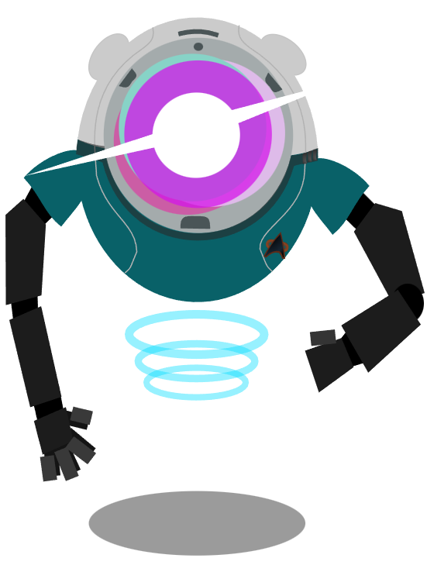
Medusan
Non-coporeal species whose ascendant physiology is dangerously incomprehensible for most people to look upon directly. In the early days, even while using filters, it required a mentally-defensive species, such as Vulcans, to gaze upon. Colonies of Medusans come in various forms as they explore the galaxy, some of the best galactic navigators. Suits developed for them create a tangible presence and shielding.

See: alt. rules in the Species Source Book, page 80.

Example Characters: Ambassador Kollos (TOS), Ensign Zero (Prodigy)

Sample Values
- We must all reach out to each other.
- I always know where I am.
- A limitation can be a freedom, and a freedom can be limiting.

Attributes: +1 Control, +1 Presence, +1 Reason

Trait: Medusan
If exposed to the raw sight of a medusan, all other species will be driven mad.

Telepathic (Species Ability)
See the Telepathy talent in the 2e Core Rulebook, page 156 for more details.

Uncanny Navigation (Medusan Talent)
Medusans have helped to improve the navigation systems built into the computer systems of all Starfleet ships, but there really is nothing like the definite article. Gain the focus Astronavigation and whenever performing a Conn task that would involve the ship, you may forgo the ship’s assistance in exchange for the first extra die, set to one.

Medusan Names
Medusans typically select short, one or two syllable names.

Examples: Farros, Iosa, Quinn, Kaftan, Algor

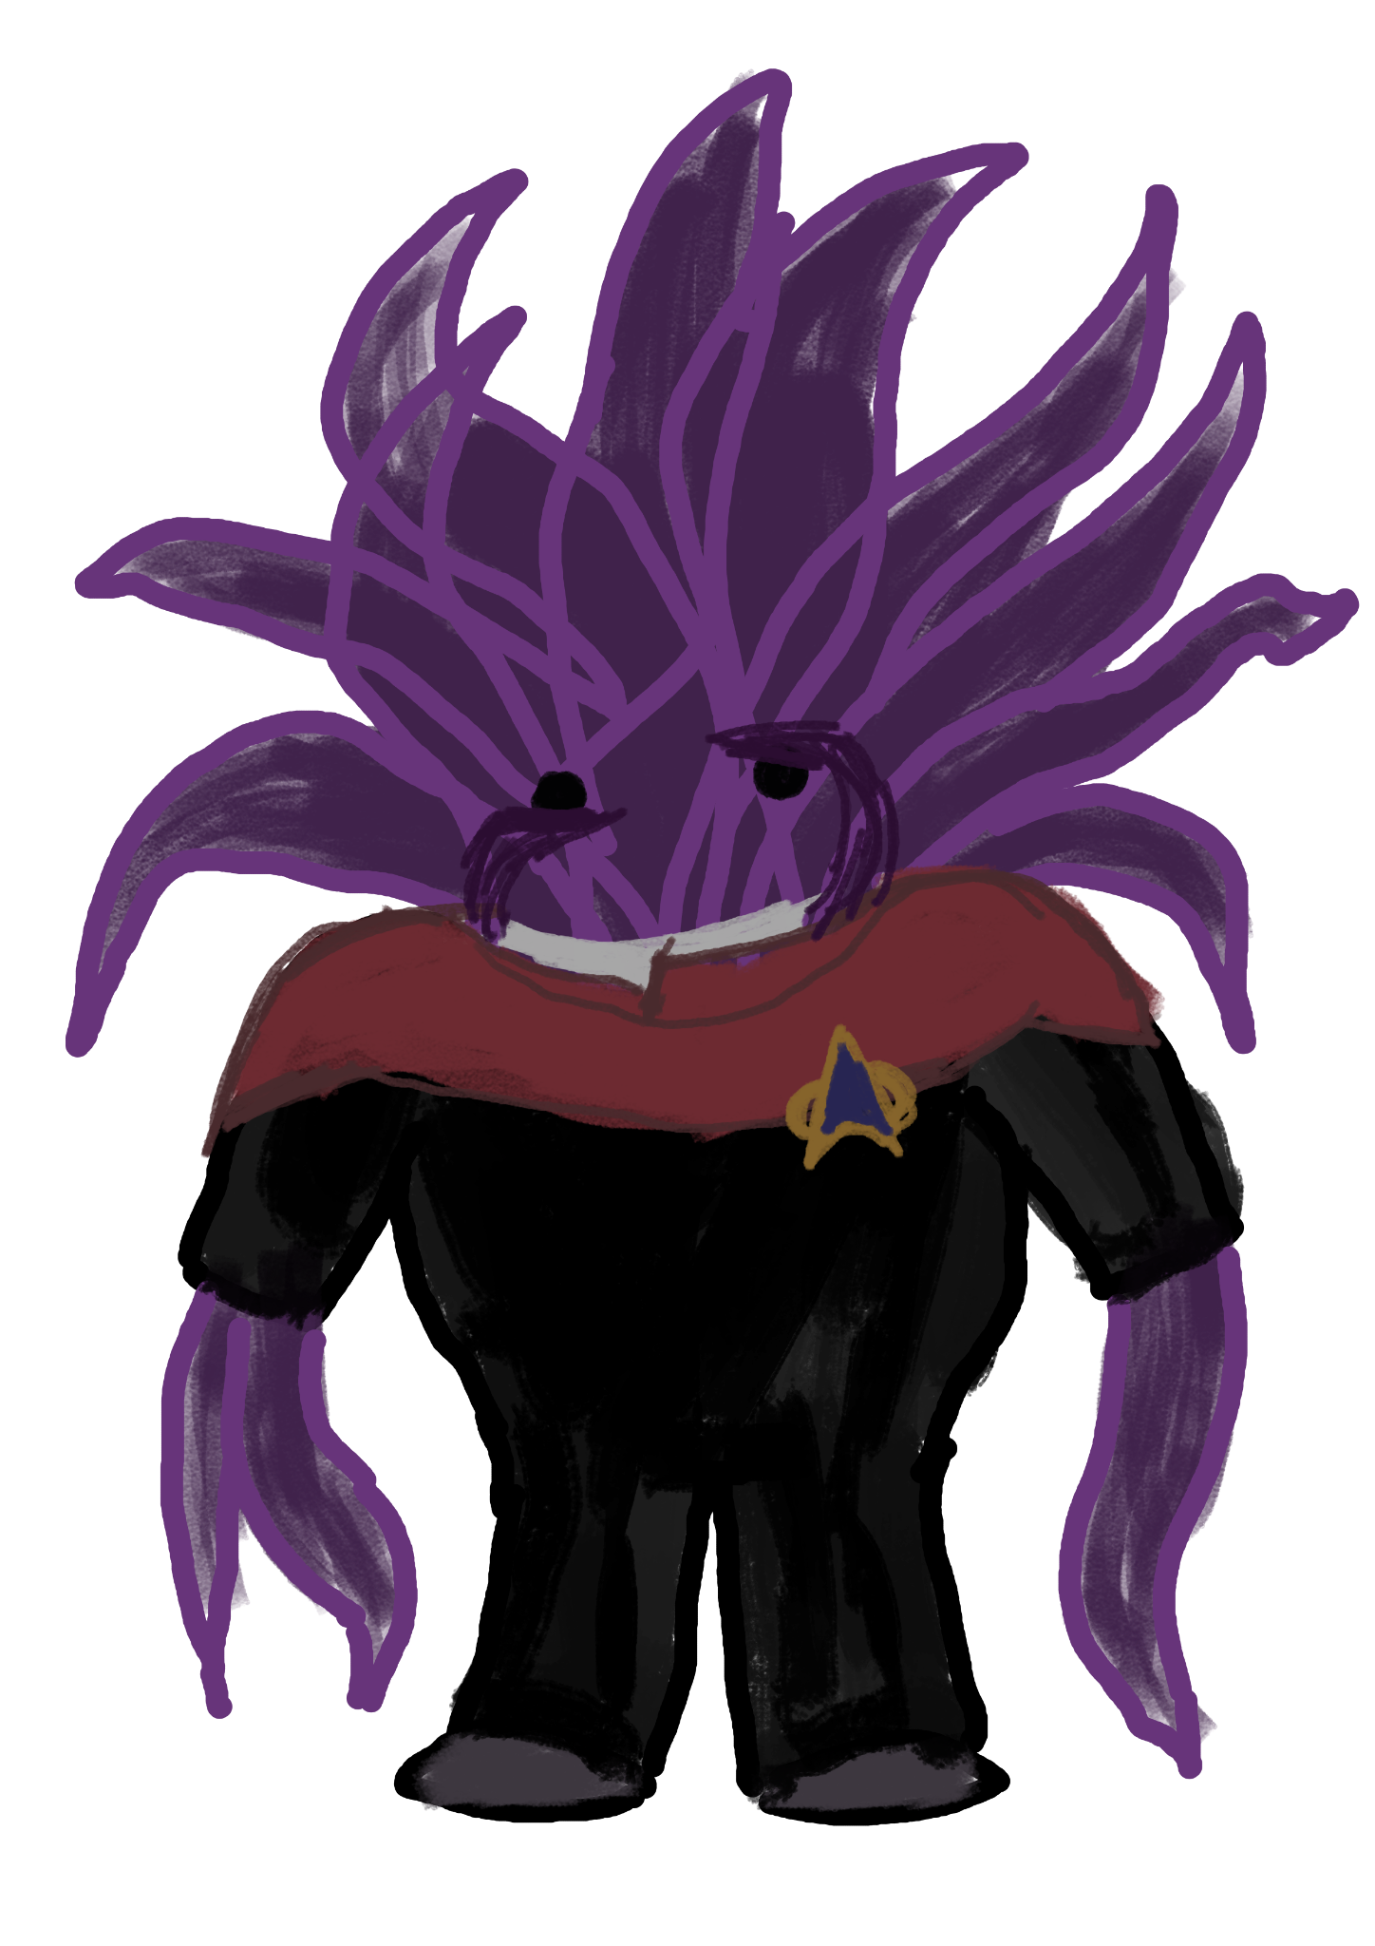
Sukhabelan

The Sukhabelans are new federation members, an Alpha Quadrant species that had gone undiscovered in the deep dark oceans and caverns of Habel IV, until their sudden experimentation with space travel in the 2290s. They’re a fun loving, curious culture eager to explore the universe and be a part of it all.

Sample Values
- Social bonds are a promise.
- Patience captures the vent-fish every time.
- Standing out doesn’t mean you can’t fit in.

Attributes: +1 Control, +1 Insight, +1 Presence

Trait: Sukhabelan
Sukhabelans are tricky to physically attack, as their tentacles are hard to land a blow on and can be made slippery when they are stressed out. The difficulty and/or complication range is increased against your attacker. On the flip side, a Sukhabelan that doesn’t keep their cool loses some of their natural dexterity for the same reason, and any task using the Control attribute has increased difficulty.

Narrow Passage (Species Ability)
They can fit into or through most spaces larger than their beaks, buried at the center of their bodies. Gain the focus Squeeze into Spaces. Additionally, gain two momentum on any scene where this character is trapped or confined.

Sukhabelan Names
Their native language on Habel IV is a tactile, touch-based one. As such, their true names are a combination of vibrations, bumps, and slides. They do, however, choose foreign nicknames which work better over audio-based translation.

Examples: Ariel, Ahtu, Inky, Kraken, Tangelle, Kraken, Nemo, Quidnuc, Scylla

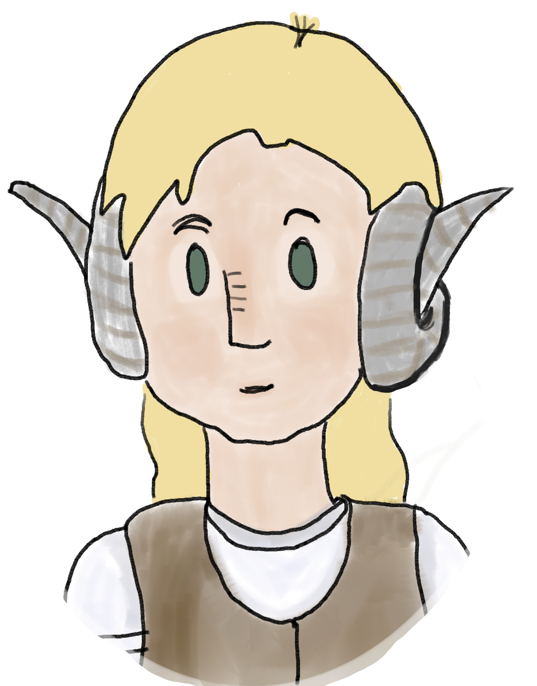
Chita-Delvan
The first native inhabitants in the Sarell Expanse to make contact with outside worlds. They hail from the fifth planet in the Chitara System. Their culture places a high value on the visual arts and theater. It is a common practice to produce short memoire holo-novellas to help others understand you.

Sample Values
- Art is the spice of life.
- To understand someone, you must act like them.
- I am compelled to capture the image of new places, people, and things.
- Nobody is too inscrutable to understand.

Attributes: +1 Control, +1 Fitness, +1 Reason

Trait: Chita-Delvan
Your attitude and behavior is said to be a pleasure to have around with any non-aggressive culture, like the Federation. You do, however, have trouble wearing hats, fitting through tight squeezes, and other head-size related tasks due to your horns.

Social Mirror (Species Ability)
You are able to mimic others like a living mirror, though you try not to since other species find it rude.
Any Task involving Social Conflict with an organic being (so not with Androids nor Borg) has the difficulty reduced by one. At the start of Social Conflict, gain one momentum automatically.

Chita-Delvan Names
Names on Chitara V are long and flowery, often consisting of a Given name, a Chosen name, a Parent’s chosen name, and “of” a quality, place, or feeling.

Examples:
- Patricia Gessana Thatch of the autumn air
- Jeffrey Herald Rouse of undying loyalty
- Alluna Fenrir Tamarin of hailstorms

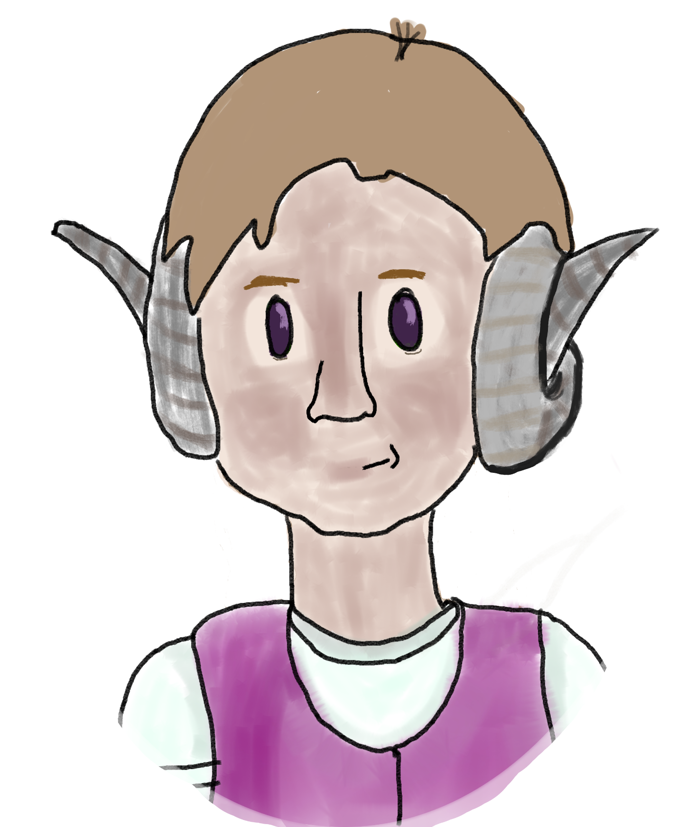
Chita-Gorvan
Related to the Chita-Delvan like the Vulcans are to the Romulans. They hail from the fourth planet in the Chitara System. They don’t like outsiders nearly as much as their cousins. They are proud hunters and engineers. Their traditions of warfare and hunting for sport are a focus of life, but not to a Hirogun degree. Their space travel is most often driven by engineering showcases or resource acquisition.

Sample Values
- Protecting my own comes before self.
- I must continue to test my body and mind.
- Smile and listen honestly, but sharpen your spear and think critically.
- My tools are an extension of my hands.

Attributes: +1 Daring, +1 Fitness, +1 Insight

Trait: Chita-Gorvan
You are viewed as honorable and wise to aggressive culture, like the Klingons or Romulans. You do, however, have trouble wearing hats, fitting through tight squeezes, and other head-size related tasks due to your horns.

Empathic Listening (Species Ability)
You are able to listen to sounds and conversations hundreds of meters away depending on noise level and obstacles. Within a shorter distance of around one hundred meters, you can sense the emotions of others if you concentrate, it does not come to you passively. See the Empathy talent on 2e Core Rulebook page 155 for examples of restrictions and reasons to increase the Difficulty of such Tasks.

Chita-Gorvan Names
The Chita-Gorvan place their family name first, and have short names, often but not always with glottal stops.

Examples: Fenrir Te’ann, Horalleo M’Geth, Sandora Chrishnelle

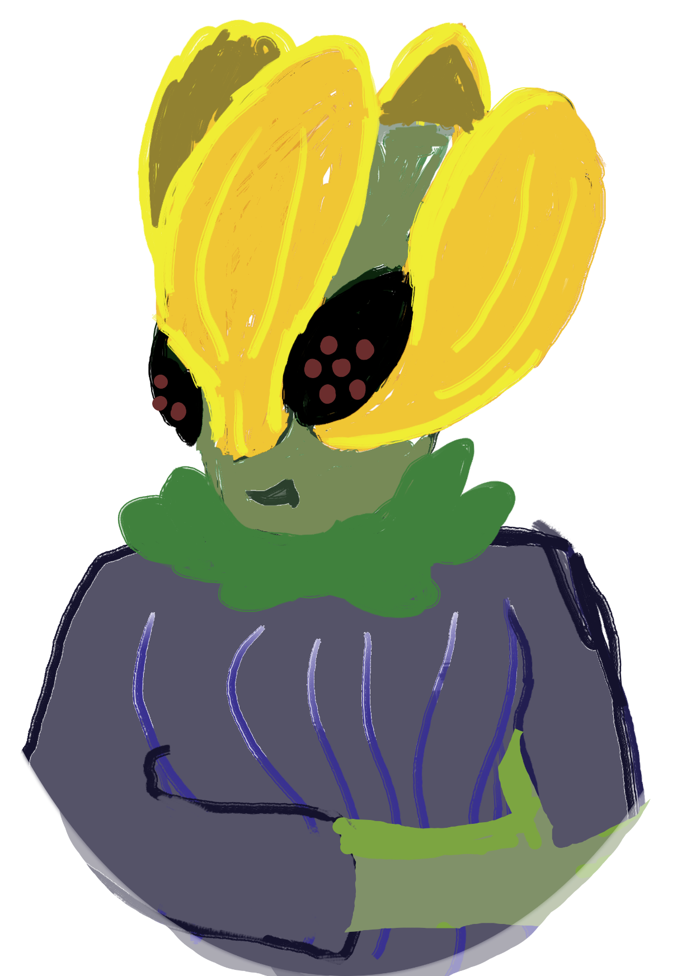
Chlomorii
Hailing from the moons orbiting Re’ath’el Major, this civilization lives in environments where the distinction between fauna and flora is thin to non-existent. Most life has evolved to absorb radiation and sunlight. The Chlomorii are hedonistic and do not value productivity as others do. Theirs would have been a Prime Directive situation, if it were not for the Chita-Gorvan forcing them to open to intergalactic trade a century ago. There are young seedlings these days who scandalously wish to travel and meet new people.

Sample Values
- Do less and enjoy it more.
- I will not work under un-cozy conditions.
- I will help others appreciate simple pleasures.
- Combat is drudgery, peace is comfortable.

Attributes:
If the character is a bold seedling: +1 Fitness, +1 Daring, +1 Presence
Otherwise: +1 Fitness, +2 Presence

Trait: Chlomorii
You are extremely low-maintenance when it comes to survivability: you require very little to stay alive. Your “skin” is closer to flowers than anything else, and you can absorb water from the air. But, you are seen as culturally high-maintenance in the eyes of outsiders, demanding levels of relaxation to rival Risa.

Motherplant Images (Species Ability)
See the Extrasensory Perception talent in the 2e Core Rulebook, page 155.
This talent comes from their long exposure to, and production of, subspace spores from the vine system that binds their moons together.

Chlomorii Names
Their species name is the longest word ever conceived of in their native tongue. Their names are commonly breathy and monosyllabic.

Examples: Soh, Ha’, Tiss, Wenn, Irh

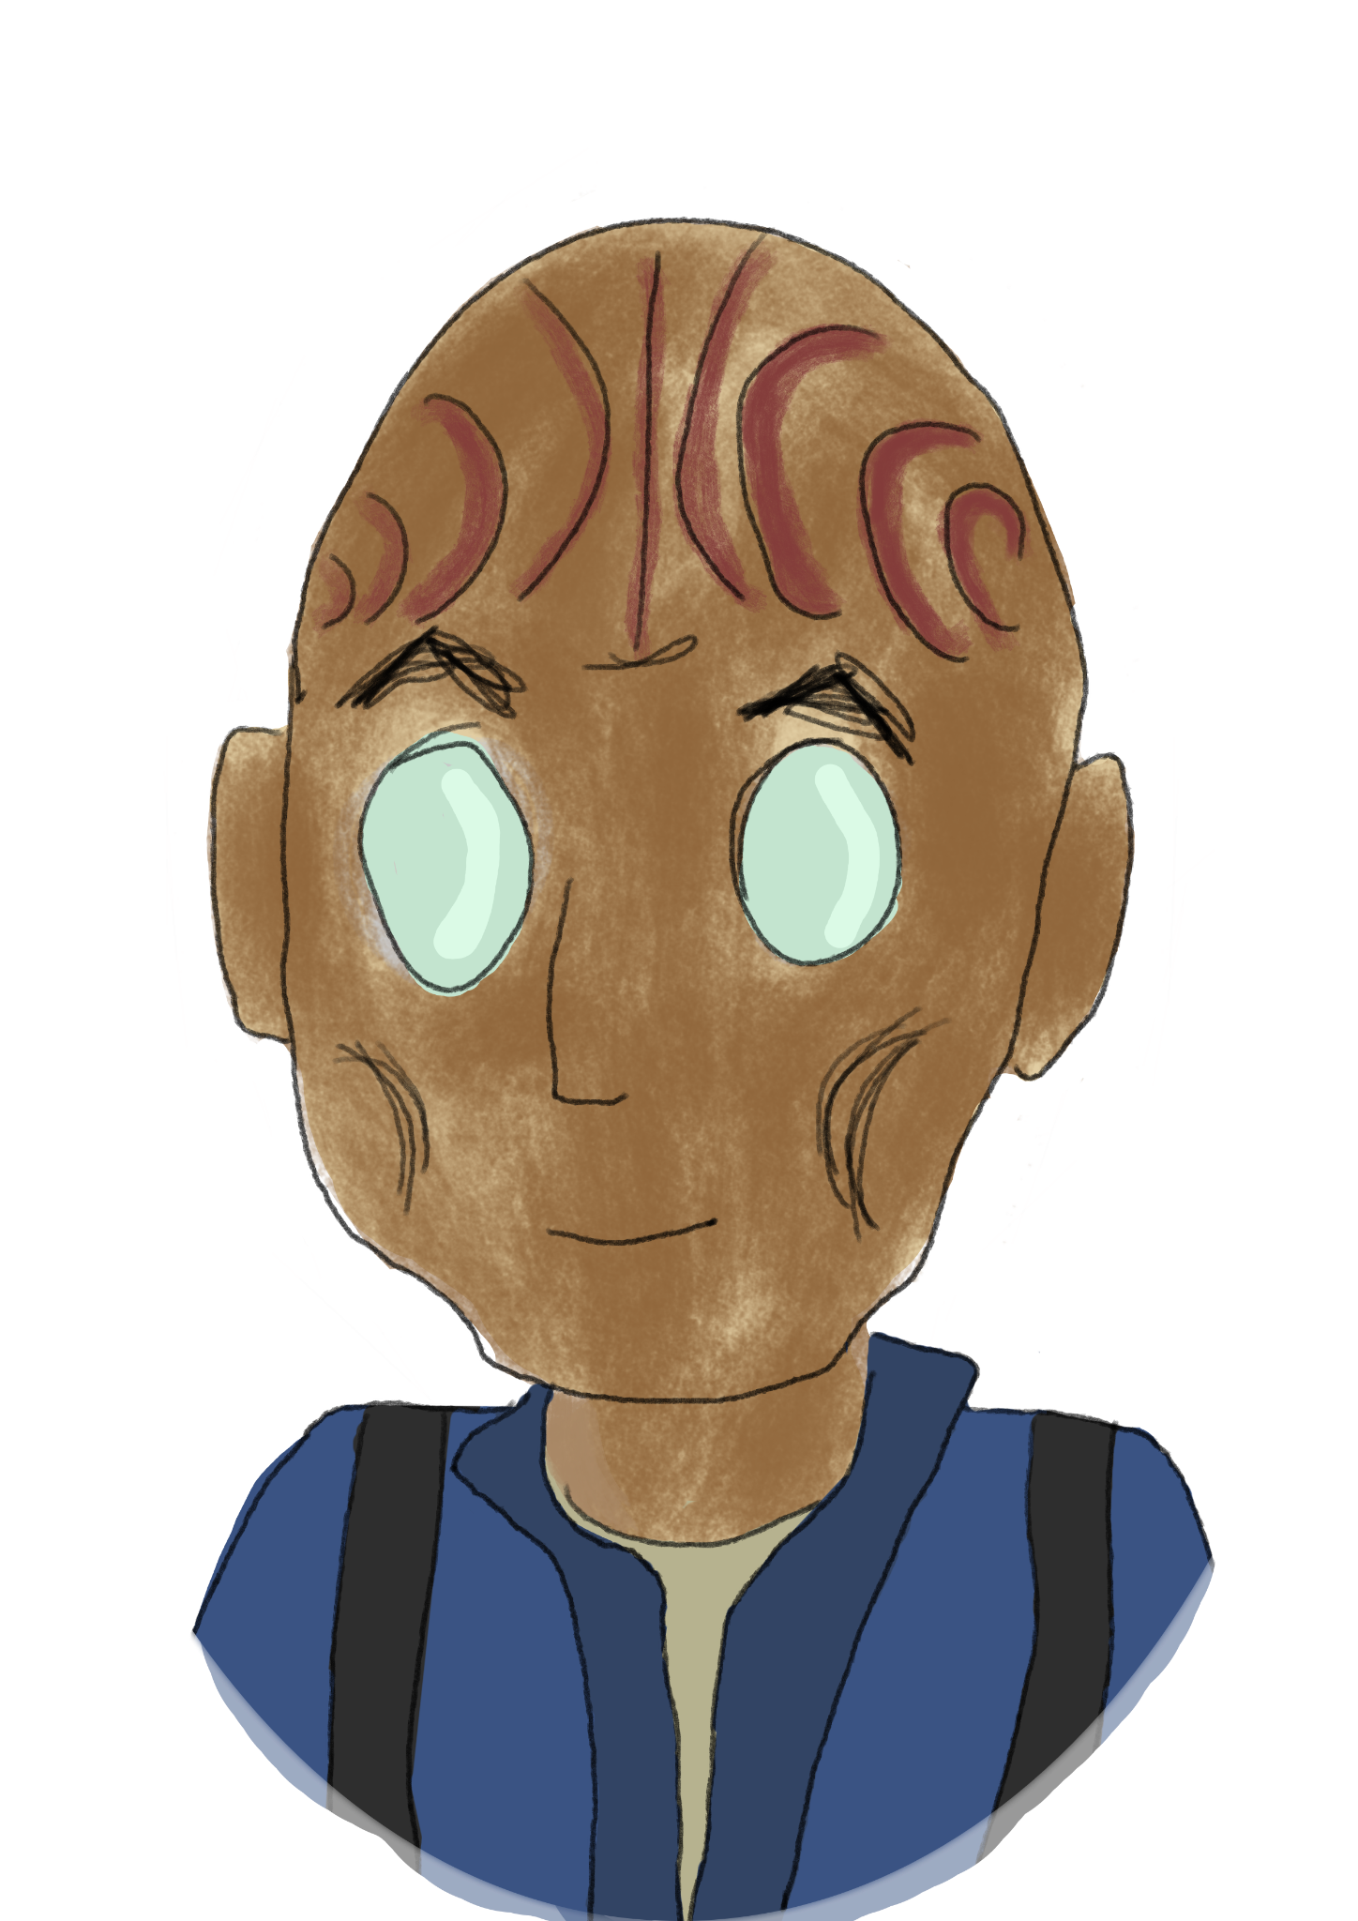
Yil
The Chita-Delvan introduced the Federation to members of this race of underground-dwellers from the Tarq system with a panchant for tapestry, cloth, communication networks, and electro-plasma systems. There are different sub-cultures of Yil which have traditions of hermitage and Yil that value community as the highest virtue. It is a constant clash that is seen as just part of the Yil tapestry, brushed off as an unchangeable fact of Yil society.

Sample Values
- Threads bind everyone together.
- A technological or ecological system is a puzzle to be understood and replicated.
- People need each other and shouldn’t be alone.
- Self-isolation can be a helpful sabbatical.

Attributes: +1 Control, +1 Insight, +1 Reason

Trait: Yil
Yil cannot see very well in lighting conditions others would find normal, and often have to wear thick sunglasses to protect their eyes at the cost of vision. However, in low-light situations, they can see clear as day. It takes a particularly uncanny void before a Yil can’t find his way around.

History of Connection (Species Ability)
Anytime you are attempting a Task involving the connection of two things, anyone can roll for “the Yil cultural heritage”, an assist that —like a ship assist— doesn’t count as the one assist allowed.

Yil Names
Yil have names similar to some earth cultures past and present, a given name and a profession or descriptor name.

Examples: Drimi Corebuild, Clarence Switchboarder, Ashara Baker, William Farmer


Sarwai
The Sarwai are an odd bunch, appearing in small numbers on a variety of worlds in the Sarell expanse. Their mouths are a visual affectation, they communicate through a sort of song and shape-shifting dance. They are not, as far as we can tell, a warp-capable species, but not unaware of space travel.

Sample Values
- For most things in life, do a little dance (either to talk about it or celebrate).
- What’s that over there?
- I come in peace.
- I want to touch or absorb more things.

Attributes: +1 Control, +1 Daring, +1 Fitness

Trait: Sarwai
Sarwai are large for extremophiles, a meter tall yet capable of existing in the deepest oceans or moons without atmosphere. Where they do not have nutrients or would be subject to dangerous conditions, they solidify for a period anywhere between two hours and a decade, but it is commonly a series of thirty-six hour cycles until the danger is passed.

Absorbent Consumption (Species Ability)
You may, as a combative act, place yourself fully or partially around something to consume. If that is an enemy, they receive one damage for every round (starting with the moment you envelop them) where they do not manage.

Sarwai Names
The universal translator cannot determine the nature of their communication, but xenosociologists are receiving intel every day. Some theorize that the Sarwai are not originally separate entities and therefore would not have names.

They are simply “Sarwai”, though peers may wish to nickname them to differentiate.

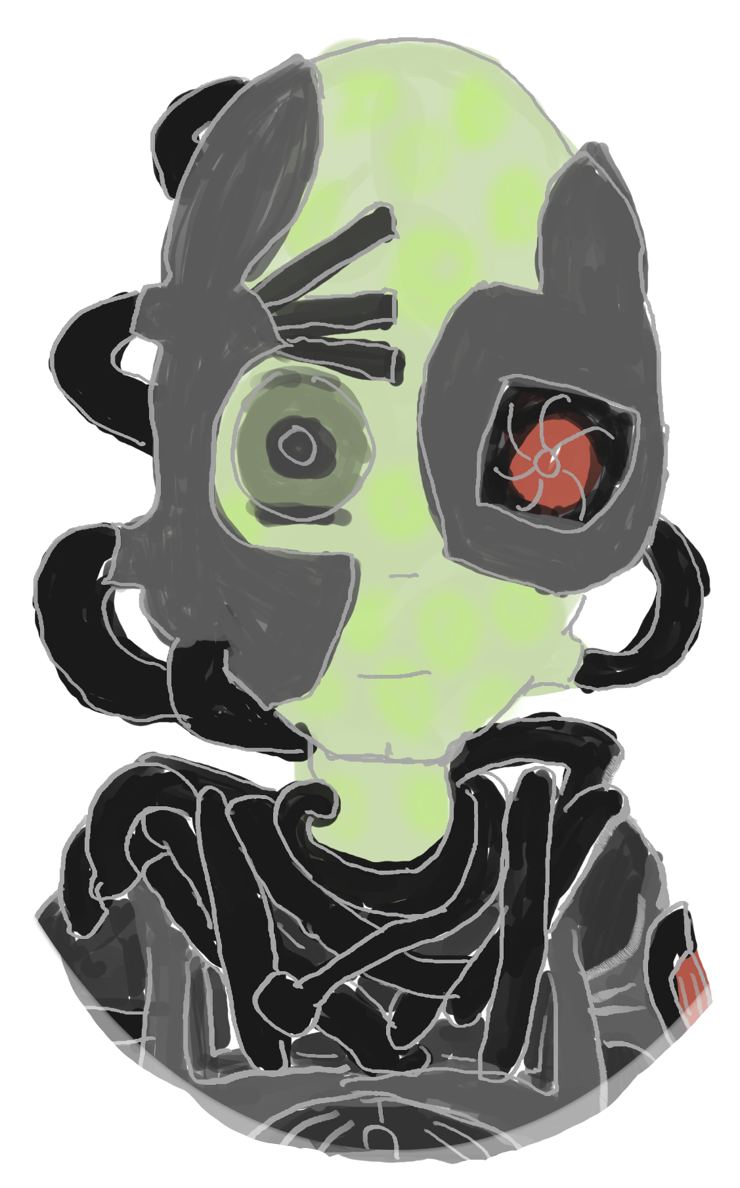
Queenless Borg
There have been many fractured offshoots of Borg from the days of Lore’s collective, to the friendlier Borg led by former Federation citizen Dr Jirati, now Queen. These however are unique a discovery. They claim to be the “original” Borg, before Temporal Cold War agents planted a single point of failure into the collective to facilitate a weakness to exploit, the Queen.

They do not use nanites or have a hierarchy. They have implants, surgery, almost-sentient ships, and they do not stop.

Sample Values
- We are the Borg, resistance is futile.
- Eventual consistency will be enforced.
- Resist the incursion, hers is a doomed call.
- Destroy all infected by the incursion.
- You are worthy of assimilation or you are beneath our attention.

Trait: Queenless Borg
You are the Borg. You are a piece of the whole, inseparable. There are many offshoots that were once Borg, but are impure and must be avoided as carriers of infected culture. You work best in warm, humid environments, but are resilient from the many assimilations of various species and technologies.

Adaptive Protection (Species Ability)
Gain a focus of the same name. Each time you are attacked by an energy or temporal weapon, perform a Fitness or Control and Security Task, difficulty 2. If you succeed, that weapon does not affect any Queenless Borg for the duration of the scene.

Queenless Borg Designations
Borg. We are Borg.
You point at another drone and declare “We are Borg”.

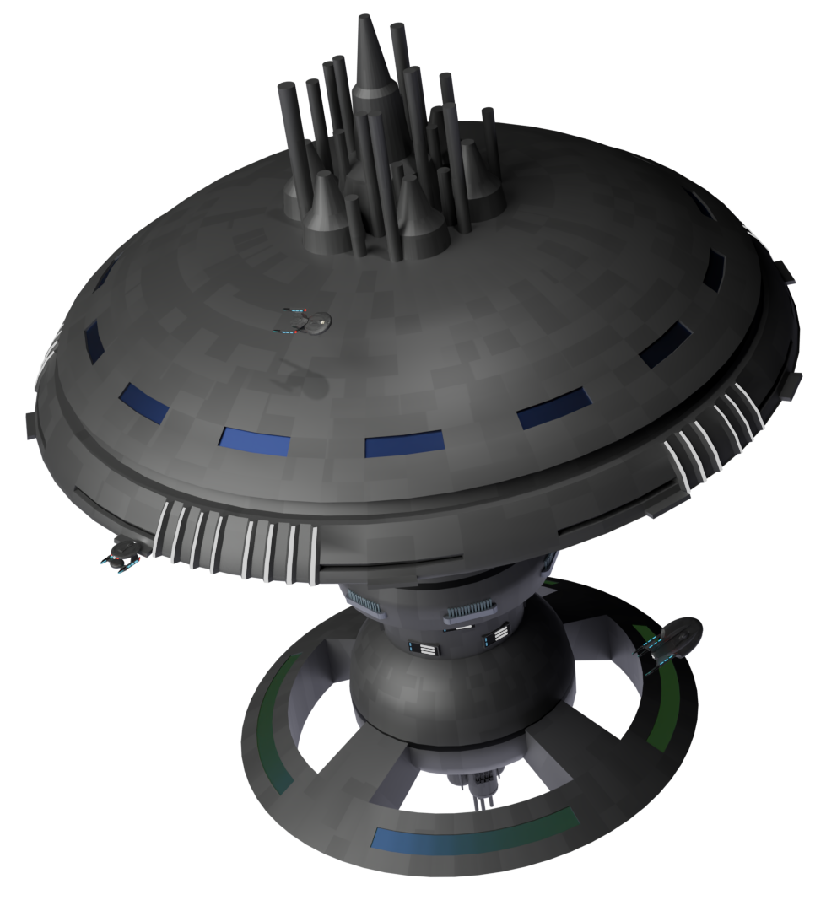
Starbase 418
A mid-24th century starbase, now retrofitted with modern facilities, engineering staff from the Andorian Shipyards, and creature comforts for civilians. The starbase has been recently positioned as the farthest permanent Federation starbase at the edge of the Delta Quadrant.

It sits free floating outside of any star system, as a moon-sized habitat and home base for all Starfleet personnel in the region.

Key administration aboard the station is the starbase’s commanding officer, Commander Frank Haskins. Coordinating the fleet in the sector is Admiral T’Vel who is among the earliest to visit the region.

The top ranking diplomats from the Sarellan Confederation are Laressa Pidora Charnum of Distant Admiration from Chitara V and Fenrir M’Gall from Chitara IV. Plenty of civilians from all species in the Confederation call home aboard the pavilion’s shops, civilian engineering bays, or the gardens in the lower ring.

Talents:
- Adaptable Energy Weapons
- Advanced Emergency Crew Holos
- Automated Defenses
- Command Ship
- Point Defense System
- Rugged Design

Traits: Federation Starbase,
Old & New Systems,
Civilians On Board
Scale: 13 Resistance: 13
Crew Support: 12 Shields: 16

Systems
Comms | 12 | Engines | 11 | Structure | 12
Computers | 11 | Sensors | 14 | Weapons | 11

Departments
Command | 4 | Engineering | 3 | Medicine | 5
Conn | 2 | Security | 4 | Science | 5

Weapons:
- Phaser Arrays
- Tractor Beams (Strength 5)

Starship Options
“…the essence of pivotal, brilliant leadership from Andoria — a fleet of ships, the finest of Federation engineering, has emerged. More than just another series of ships, they symbolize science, responsiveness, and preparedness in the further pursuit of exploration beyond every horizon. As these ships launch, they carry the Federation's hopes, acting as emissaries of peace and knowledge. We commend the Andorian shipyards' exceptional work and wish the crews godspeed in the Sarelle Expanse.” — Fleet Admiral Ch’Thallzus

After the disaster crippling Utopia Planitia in 2385, a handful of federation member worlds were selected to construct or expand their own shipyards, both to cover for the ship-building needs of Starfleet while it rebuilt, but also to avoid the possibility of having a single point of failure again.

All of the following starship classes hail from the Andorian Shipyards have an effective Launch Year of 2407, and as such none are up for a refit according to the recommended timeframe of the campaign.

New Starship Talent

Hydroponics Bay
Once per adventure, you may create a Local Delicacies or Real Food trait for free. When a character performs a Rest which narratively includes eating, add +2 Momentum.

New Mission Pod
This mission takes place after many years of Starfleet experimenting with and utilizing mission pod technology. The Hugo class is the new carrier of this torch, and they’ve come up with more specialities for it.

Extended Mission Support
Gain two of the following starship talents:
Hydroponics Bay, Backup EPS Conduits, Expanded Emergency Medical Facilities, Expanded Munitions, Extensive Shuttlebays, Improved Power Systems,
Improved Probe Bay, Redundant Systems (X), Secondary Reactors,
Sophisticated Astrometrics Facilities, or Wormhole Relay System

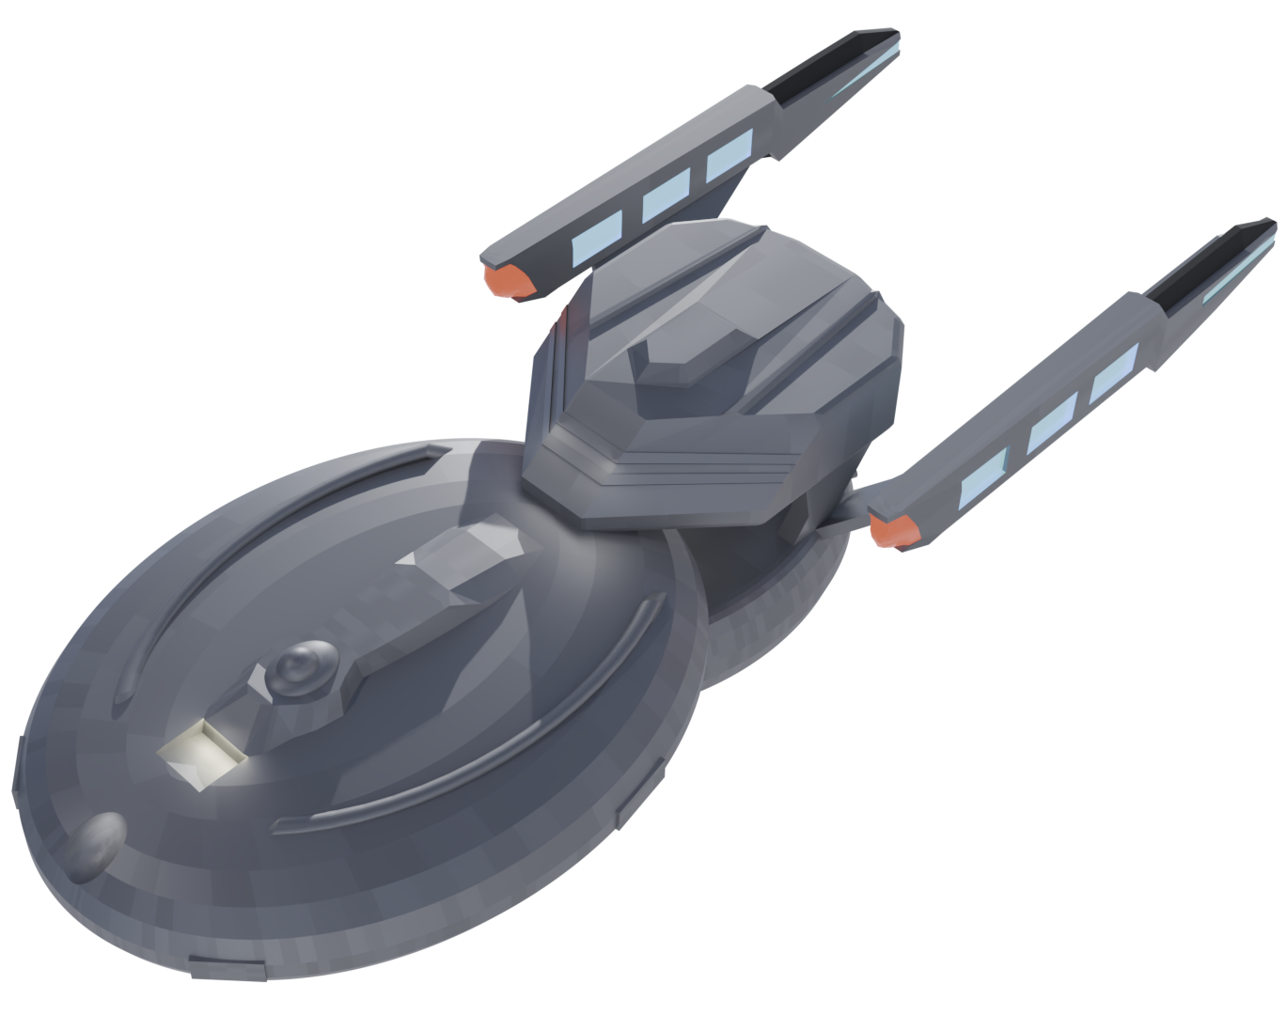
Hugo Class
Generally, ships of this class are named after famous Authors.

They have a strong focus performing large scientific projects, as mobile hospitals, as launch platforms for small fighters, or host of other specialized missions thanks to its mission pod. Inspired by the Intrepid class but with greater modularity of the Nebula or Sutherland classes.

Example Ship Names:
- U.S.S. Shakespeare
- U.S.S. Wilde
- U.S.S. Kafka
- U.S.S. Shelley
- U.S.S. Hemingway
- U.S.S. Dickens

Suggested Mission Pods
As the hero ship of a campaign:
- Astrometrics and Navigation
- Fleet Command Support¹
- Sensors¹
- Advanced Research Facilities¹
- Extended Mission Support

Suggested Mission Profiles
- Flagship
- Multirole Explorer²
- Pathfinder and Reconnaissance Operations²
- Strategic and Diplomatic Operations²

Traits: Federation Starship, Hugo class
Scale: 4

Systems
Comms | 9 | Engines | 10 | Structure | 9
Computers | 10 | Sensors | 10 | Weapons | 9

Departments
Command | +1 | Engineering | — | Medicine | —
Conn | — | Security | — | Science | +1

Weapons:
- Phaser Arrays
- Phaser Banks
- Quantum Torpedoes
- Tractor Beam (Strength 4)

Special Rule: Mission Pod¹

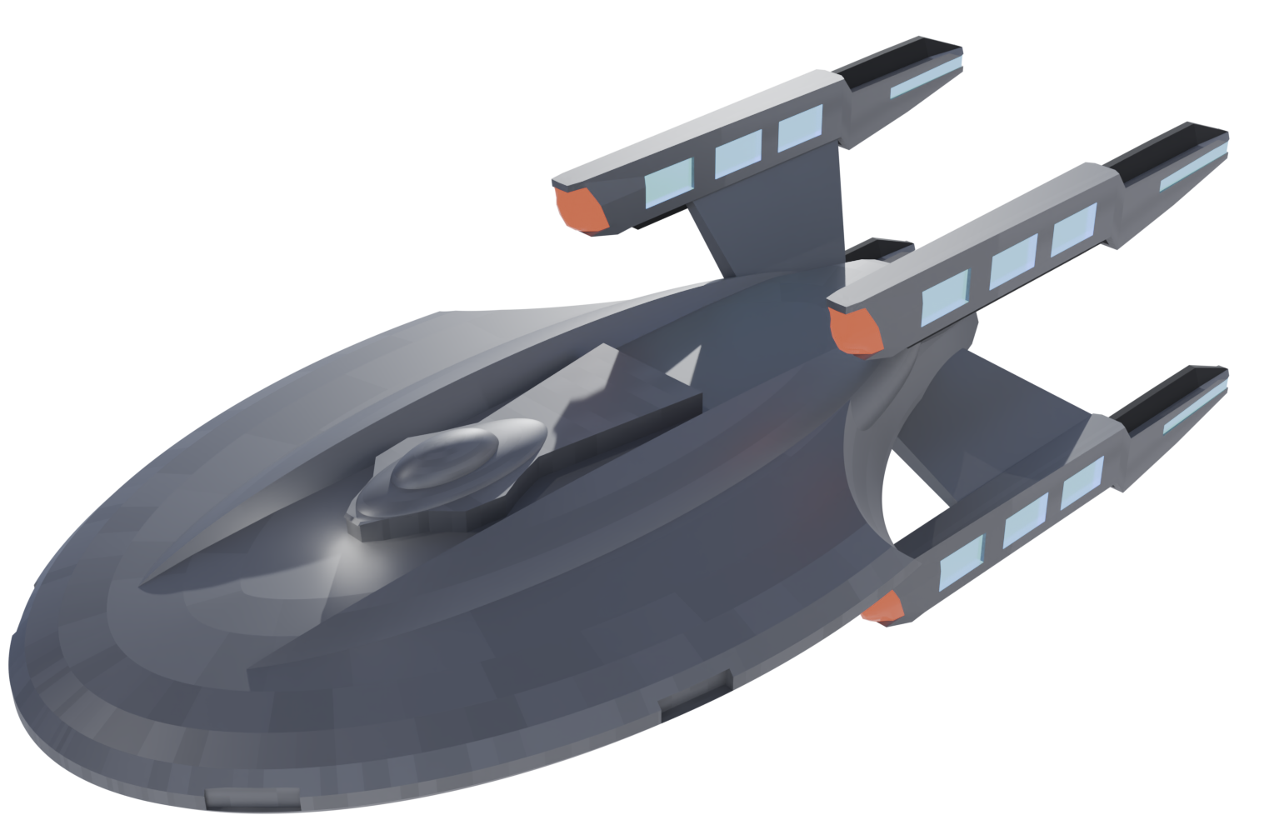
Pendragon Class
Generally, ships of this class are named after mythological figures and places of legend.

They are powerful responders designed for high warp and defense for the outer reaches of federation space.

Example Ship Names:
- U.S.S. Excalibur
- U.S.S. Camelot
- U.S.S. Avalon
- U.S.S. Lancelot
- U.S.S. Guinevere
- U.S.S. Merlin

Suggested Mission Profiles
- Strategic and
- Diplomatic Operations
- Crisis and Emergency Response³
- Multirole Explorer³
- Flagship³

Traits:
Federation Starship, Pendragon class
Scale: 5

Systems
Comms | 9 | Engines | 12 | Structure | 8
Computers | 10 | Sensors | 9 | Weapons | 9

Departments
Command | — | Engineering | — | Medicine | +1
Conn | +1 | Security | +1 | Science | —

Weapons:
- Phaser Arrays
- Phaser Banks
- Quantum Torpedoes
- Tractor Beam (Strength 2)

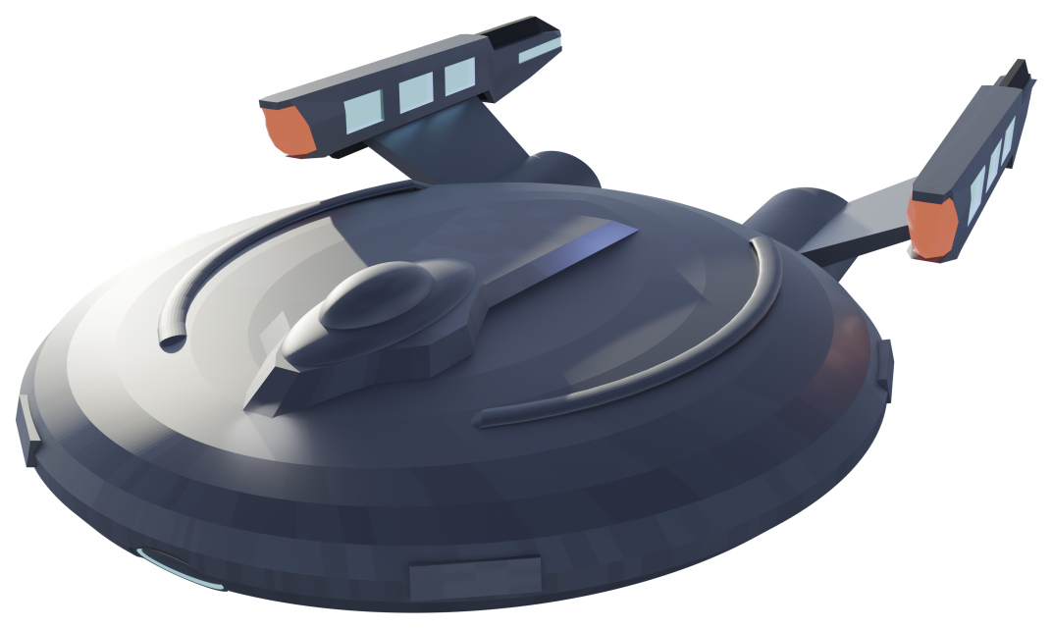
Ch’thoran Class
Generally, ships of this class are named after elements of a tundra climate.

The ship combines powerful impulse engines and a rounder frame to create an excellently maneuverable ship - for navigating asteroid fields, entering combat against nimble foes, or entering into zones with odd gravity wells.

Example Ship Names:
- U.S.S. Glacier
- U.S.S. Tundra
- U.S.S. Alpine
- U.S.S. Permafrost
- U.S.S. Svalbard
- U.S.S. Borealis

Suggested Mission Profiles
- Tactical Operations
- Battlecruiser⁵
- Patrol⁵
- Crisis and Emergency Response⁵

Traits:
Federation Starship, Ch’Thoran class
Scale: 3

Systems
Comms | 9 | Engines | 9 | Structure | 8
Computers | 9 | Sensors | 9 | Weapons | 12

Departments
Command | — | Engineering | — | Medicine | —
Conn | +2 | Security | +1 | Science | —

Weapons:
- Phaser Arrays
- Quantum Torpedoes
- Tractor Beam (Strength 1)

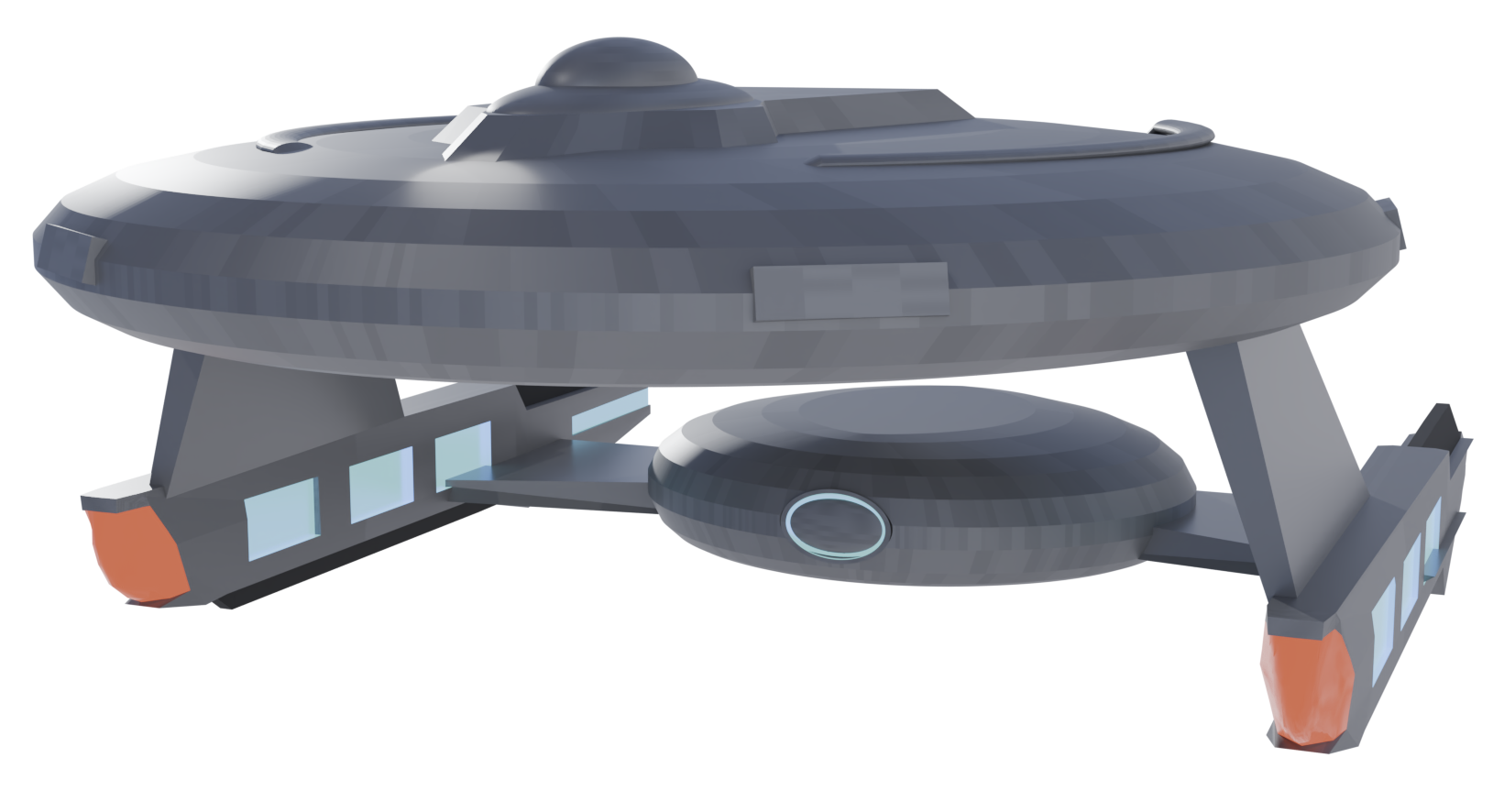
Durian Class
A workhorse ship inspired by the famously sturdy California class, the Durian class is highly adaptable, but never the fastest, most powerful, or most sensor-equipped.

Ships of this class leave spacedock with a particular class of mission in mind and stick to that until refit or decommission.

Example Ship Names:
- U.S.S. Durian
- U.S.S. Decorum
- U.S.S. Cempedak
- U.S.S. Prediction
- U.S.S. Calabash
- U.S.S. Ratchet

Suggested Mission Profiles
- Logistical/Quartermaster
- Colony Support⁶
- Reserve Fleet⁶
- Scientific and Survey Operations
- Crisis and Emergency Response⁷

Traits:
Federation Starship, Durian class
Scale: 4

Systems
Comms | 10 | Engines | 9 | Structure | 7
Computers | 10 | Sensors | 9 | Weapons | 8

Departments
Command | — | Engineering | +1 | Medicine | —
Conn | — | Security | — | Science | +1

Weapons:
- Phaser Banks
- Photon Torpedoes
- Tractor Beam (Strength 3)

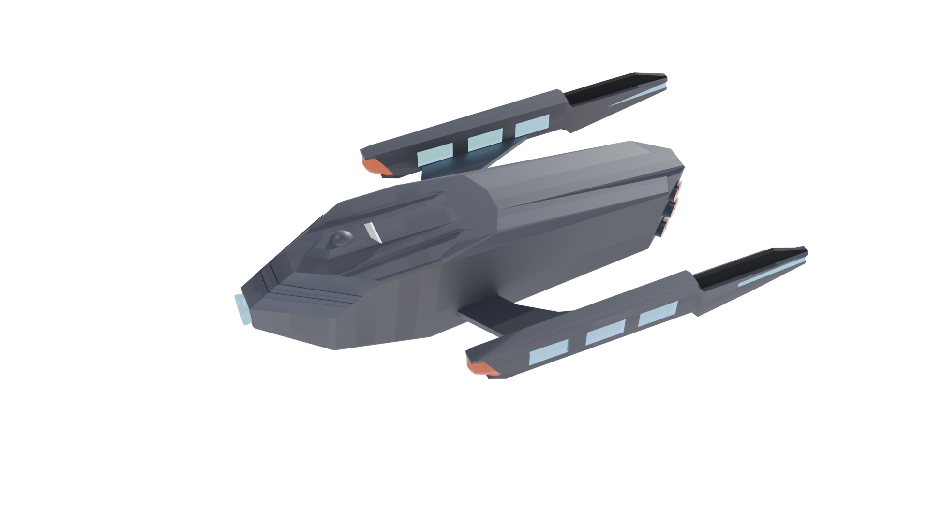
Borushaa Class
Generally, ships of this class are named after non-Earth UFP member planets.

Harkening back to older designs of pre-Federation Andoria, the Borushaa class is primarily a people-mover and a cargo carrier. The ships are meant to bring a lot of anything across the galaxy.

Example Ship Names:
- U.S.S. Andoria
- U.S.S. Denobula
- U.S.S. Tellar
- U.S.S. Betazed
- U.S.S. Minos
- U.S.S. Rigel

Suggested Mission Profiles
- Colony Support
- Crisis and Emergency Response⁷
- Tactical Operations⁷
- Battlecruiser⁷

Traits:
Federation Starship, Borushaa class
Scale: 3

Systems
Comms | 7 | Engines | 9 | Structure | 10
Computers | 9 | Sensors | 8 | Weapons | 10

Departments
Command | — | Engineering | +1 | Medicine | —
Conn | — | Security | +1 | Science | —

Weapons:
- Phaser Banks
- Quantum Torpedoes
- Tractor Beam (Strength 4)

Shuttlecraft

Aquarius-class Escort
These specialized small craft are available in this era.
See page 23 of the 2e Game Toolkit Booklet.

Type 12 Shuttlecraft
A sleek shuttle seen in future segments of the Voyager finale, it is the early 25th century equivalent to the Type 6, with slight design cues from the delta flyer.

Use the Shuttlecraft stats from page 233 of the 2e Core Rulebook. If there are older shuttle types, such as Type 6, encountered in an adventure - it is recommended to downgrade the stats of them to keep the ship balance in check.

Type 14 Shuttlecraft
A warp capable small craft with more room and comfort than a Type 12 shuttle. Seen in Star Trek Picard season 3.

Use the Runabout stats from page 234 of the 2e Core Rulebook. If an actual Runabout is seen in this era, downgrade it to keep it balanced against these new ships.

Expanse Technology and Gear

The universe is advancing, our gear needs to be more flexible, more reliable, and sleeker to keep up with civilian technology and the demands of a 25th century explorer.

New Comm Badges
With a copper-like backing and a dark blue metal center, it’s less bold and brash than previous badges, especially on the standard Sarell-Mission Uniform.

Otherwise, this 25th century comm badge has the standard features expected of a 24th century one:
- Communicator
- Location Beacon
- Transport Signal Enhancer

Additional functionality packed in:

Vocal LCARS access
For personal / officer’s log recording or querying the ship computer. The user can say “computer” to use the paired ship (usually your assigned one). If you state the name of a craft before “computer” the badge will try using that computer, or give a failure chirp.

Basic Holography
Small, short-throw holographic imagery with very minimal interactivity, projected into hand or just in front of the user’s vision
Useful for displaying a map or sharing a 3D image
Effectiveness / brightness drastically reduced at distance or scale - can be overridden at the expense of overheating the badge, requiring cooldown and repair.

Protective Gear
New options for protection during engagements, both to avoid and survive fights.
See pages 244 and 245 of the 2e Core Rulebook for armored vests and environment suits, and in addition - this campaign adds the following:

Name | Protection | Cost
Borg Shielding | *see description | Opportunity 2, Escalation 2
Temporal Shielding | 2* | Opportunity 2, Escalation 2

Borg Shielding
Starfleet experimented with a variety of borg technologies recovered from the decimated foe, during the 2290s especially. The constantly-adapting personal shielding technology is risky to use, partly because it can glitch out and fail at unexpected times, and partly because the array of small devices to make it work need to be connected to a network that is similar enough to any Borg channels, that one may be seen as a threat or source of strategic information from nearby Borg remnants. Starfleet only employs this in the most dangerous or dire of circumstances, and it’s not been proven in the field for long.

With the Borg Shielding equipped, perform a Control or Daring and Engineering Task, difficulty zero and complication range of 1, when attacked by a ranged weapon; the protection amount is the number of successes. No momentum can be gained from this roll.

Temporal Shielding
A personal shield module which normally only protects against Temporal Injuries.
Traits may be added to temporarily increase the protection or apply the protection for non-temporal attacks.

Weapons
Weaponry has changed now that it’s a bold new century, especially in the expanse.

Symbol Key
 | Ranged |  | Melee

Name | Type | Injury | Severity | Size | Qualities | Cost
Akat Blade |  | Deadly | 3 | 1H | Accurate, Debilitating | Opportunity 1, Escalation 1
Force-Field Gauntlets |  | Stun | 3 | 1H | Accurate, Cumbersome, Hidden 1, Piercing | Opportunity 1, Escalation 1
Phaser Type-1E (2403+) |  | Stun, Deadly | 4, 3 | 1H | Charge, Self-Diagnostics, Hidden 1 | Standard Issue
Chitaran Disruptor Pistol |  | Stun, Deadly | 2, 4 | 1H | Charge, Accurate | Not Available
Temporal Grenade X |  | Temporal Area | X | 1H | Area, Cumbersome, Grenade, Hidden 2 | Not Available, Escalation 3
Phaser Bazooka |  | Deadly | 6 | 2H | Cumbersome, Debilitating, Intense, Inaccurate | Opportunity 1,  Escalation 3

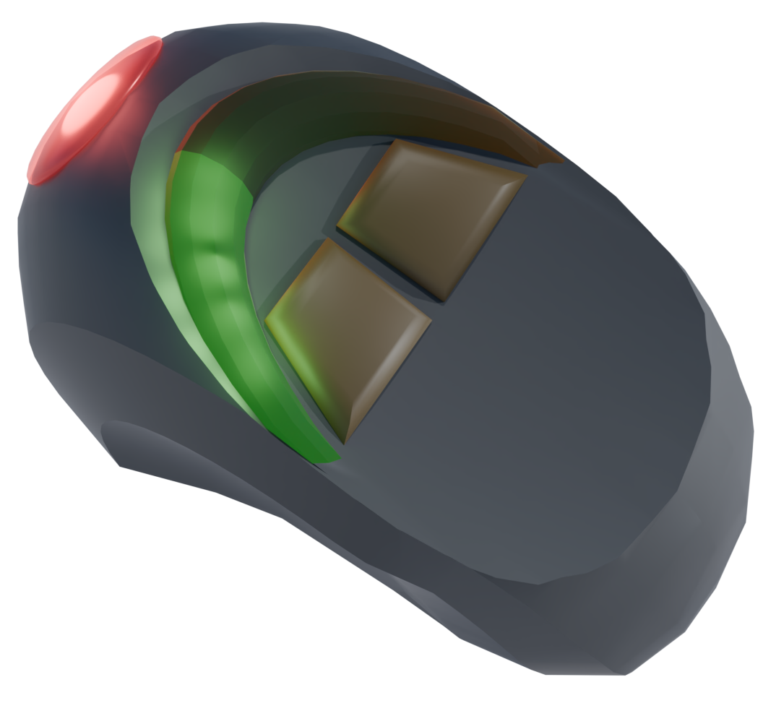
Phaser Type 1E - the 2403+ Update
Concerned with the normalization of the larger, deadlier type 2, 3, and 1A phasers due to years of ongoing conflicts, Starfleet deigned it necessary to update and modernize the model once issued as the main phaser in the fleet.

Variable Output Refinement
Users can dial in specific power levels with greater accuracy on the type 1E, allowing for fine-tuned control over the phaser’s effects. Visual and haptic feedback systems provide real-time data on the energy output, allowing for more intuitive adjustments and versatility. The stun capabilities are more powerful than its deadly setting, and the separate severities reflect that.

Self-Diagnostics
The phaser has enhanced diagnostics providing real-time feedback on power levels, heat buildup, and internal component status. This new Quality reduces the Difficulty of any Engineering Tasks to repair or maintain the phaser by one.

Concealability
Emphasis on the "small, concealable" aspect is maintained, making it an ideal sidearm for undercover operations or when discretion is needed and minimizes the militaristic appearance of the officers on mission without leaving them unprotected.

Chitaran Disruptor Pistol
Popular across the Expanse, originating from the Chita-Gorvans, it has some small cosmetic differences from its counterparts in the Romulan Free State or Klingon Empire, and does have a “wound” setting that is effectively a stun.

Akat Blade
The Akat blade is a ceremonial sword originating from the Yil and used by warriors on planets that do trade within and with the Confederation. Forged using unique metallurgical processes, the blade maintains an incredibly sharp edge and resonates with a subtle energy field, enhancing its cutting power. It is often considered a symbol of honor and skill among certain cultures within the expanse.

Temporal Grenade
The time war bleeds through and harms all it touches. One of the nasty devices that have been seen is the Temporal Grenade. It’s not meant to do physical harm so much as it’s an existential, disruptive-to-continuity threat.
New Injury type, “Temporal Area”: For the next three rounds after detonation, the area within Close range is subject to minor temporal distortions. Characters starting their turn in the area must make a Difficulty X Control + Science check or lose their next minor action.

Phaser Bazooka
Once exclusive to the realms of over-the-top holo-novels in the holodecks of the Cerritos, lower deck engineers since then have been inspired to build it for real. It’s unwieldy and impractical — this personal phaser canon is something that is better mounted on a shuttle. It has been used as siege weaponry, to bust down stronghold doors, so Starfleet has made the replicator plans available despite the drawbacks.

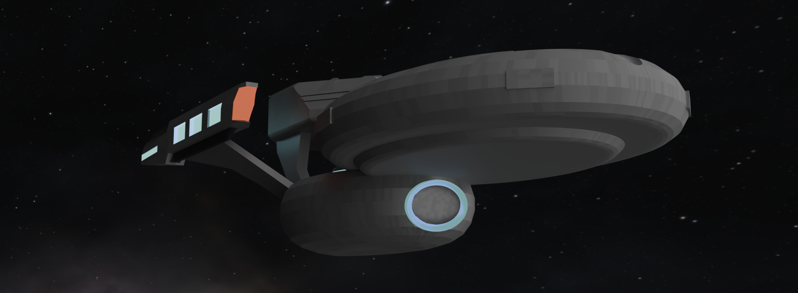

U.S.S. Frost NCC-92135

Newly assembled crew and our best veterans and our brightest up-and-comers. Ready to lead the charge as the first in its class.

Launch Year, Timeframe: 2307
Mission Profile: Flagship
Traits: Federation Starship, Hugo Class
Scale, Resistance, Crew Support: 4
Shields (16):
❑❑❑❑❑❑❑❑
❑❑❑❑❑❑❑❑

Talents:
- Command Ship
- Dedicated Subspace Transceiver Array
- Advanced Emergency Crew Holograms
- High Resolution Sensors

Special Rule: Mission Pod
Mission Pod: Extended Mission Support
Mission Pod Talents:
- Hydroponics Bay⁸
- Sophisticated Astrometrics Facilities

Systems
Comms | 10 | Engines | 10 | Structure | 9
Computers | 10 | Sensors | 10 | Weapons | 9

Departments
Command | 4 | Engineering | 2 | Medicine | 1
Conn | 1 | Security | 3 | Science | 2

Weapons
Phaser Arrays | 6
Versatile 2, Area or Spread | Medium Range
Phaser Banks | 7
Versatile 2 | Medium Range
Quantum Torpedoes | 8
Calibration, High Yield, Intense | Long Range
Tractor Beam | 4
See the 2e Core Rulebook, page 231

Captain Clemente J. Jackson
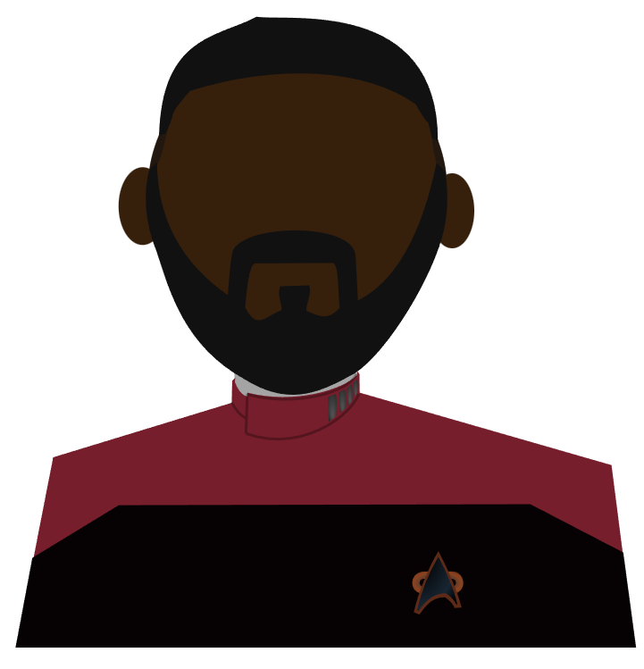
Growing up in a far-flung colony, Jackson always had endless hills and valleys to explore. He took that zeal into his career in a way that’s infectious. His first few tours were disaster relief for homeworlds. Once captain, he signed up for every distant star he could. He has a good relationship with his daughter and her mother who do their own travelling, they talk often.

Role: Commanding Officer
Traits: Human, Starfleet Officer
Age: 35
Values:
- Exploration is what life is all about.
- The prime directive prevents us from repeating the pasts’ mistakes.
- New cultures are a worthwhile double-edged sword.
- Doing a steady, thorough job is important for your reputation.
Focuses: Debate, Starfleet Protocols, Shield Harmonics, Diplomacy, Quantum Mechanics, Philosophy
Pastime: Scuba Diving
Stress (9): ❑❑❑❑❑❑❑❑❑

Attributes
Control | 9 | Fitness | 9 | Presence | 10
Daring | 10 | Insight | 7 | Reason | 11

Departments
Command | 5 | Engineering | 1 | Medicine | 2
Conn | 2 | Security | 3 | Science | 3

Attacks
Unarmed Strike
Melee, Stun 2, Intense, 1H
Phaser Type 1E
Ranged, Stun 4 / Deadly 3, 1H, Charge

Abilities & Talents:
- Faith of the Heart (Species Ability): 2e Core Rulebook page 107. When Jackson uses Determination, gain 1 momentum.
- Decisive Leadership:
2e Core Rulebook page 157.
- Call to Action:
2e Core Rulebook page 157.
- Voice of Authority:
2e Core Rulebook page 150.
- Advisor:
2e Core Rulesbook page 156.
- Commanding Officer (Role Benefit): 2e Core Rulebook page 135.

Alden Galarus A.I.H
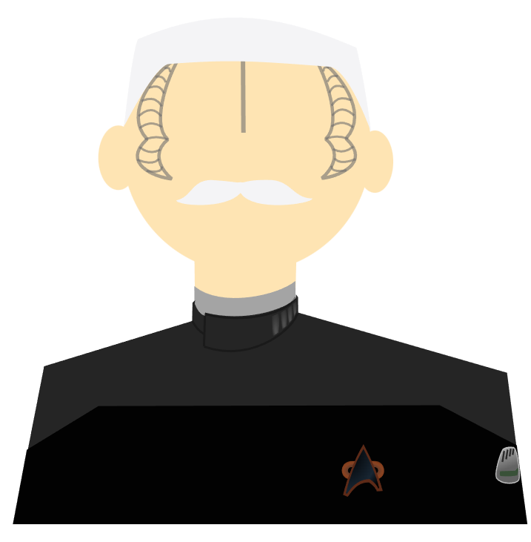
Former Captain of the USS Earhart-C, died Admiral, and long servant of the department of temporal investigations captured his likeness for use by future captains as the “Assignment Intelligence Hologram” or IAH. He has a lot of stories and scars from the Dominion War they couldn’t program out.

Role: Intelligence
Traits: Hologram, Denobulan, Intelligence Operative
Age: 163 (153 living, 10 as a hologram)
Values:
- The universe is far more vast and complex than just our space.
- A loss is acceptable if we gain enough from it.
- We must have hope and ideals, or we have lost what we fight for.
- Training the next generation right is extremely vital.
Focuses: Investigation, Temporal Mechanics, Inspiration, Emergency Protocols, Instructing, Cultural Nuances
Pastime: Designing Escape Rooms
Stress (9): ❑❑❑❑❑❑❑❑❑
Attributes
Control | 11 | Fitness | 9 | Presence | 8
Daring | 8 | Insight | 12 | Reason | 8

Departments
Command | 4 | Engineering | 3 | Medicine | 1
Conn | 2 | Security | 4 | Science | 2

Attacks
Unarmed Strike
Melee, Stun 2, Intense, 1H
Phaser Type 1E
Ranged, Stun 4 / Deadly 3, 1H, Charge

Abilities & Talents:
- Breadth of Study (Species Ability): 2e Core Rulebook page 105. When Galarus has 2 additional focuses.
- Mobile Emitter: The IHA possesses a special device that allows him to move and act in areas without holo-emitters. Complications that may arise when this device is damaged will cause issues with the projection.
- Neural Interface: 2e Core Rulebook page 155.
- Cultural Flexibility: 2e Core Rulebook page 152.
- Command & Control: Technical Manual page 11.
- Veteran: 2e Core Rulebook page 128.
- Intelligence Agent (Role Ability): 2e Core Rulebook page 128.

Commander Tove Marla
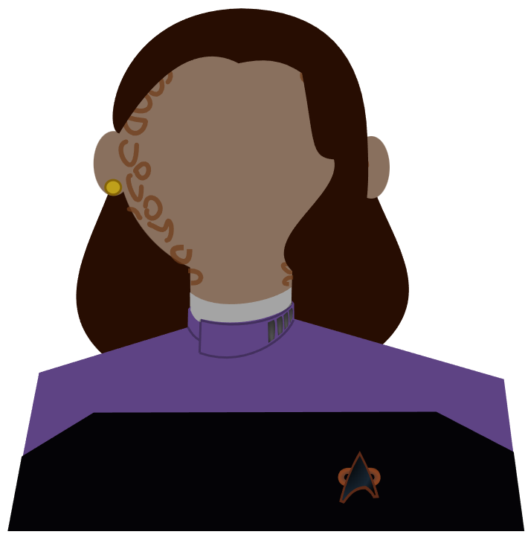
Passionate, sharp, lover of puns. Entered Starfleet to help the galaxy heal. This is the second ship she’s been the CMO for, before this post she was the Doctor for Starbase 701.

Role: Chief Medical Officer
Traits: Trill, Starfleet Officer
Age: 39
Values:
- It can be freeing not to be the center of attention.
- Mental and physical health are intimately linked.
- People are too eager to believe they’re better when the medicine, actual or metaphorical, is working.
- I’m responsible for the whole crew.
Focuses: Animal Handling, Psychiatry, Genetics, Neurology, Sociology, Hand-to-hand combat, Infiltration cosmetics
Pastime: Musical Theater
Stress (12): ❑❑❑❑❑❑❑❑❑❑❑❑

Attributes
Control | 10 | Fitness | 12 | Presence | 9
Daring | 7 | Insight | 8 | Reason | 10

Departments
Command | 2 | Engineering | 1 | Medicine | 5
Conn | 2 | Security | 3 | Science | 3

Attacks
Unarmed Strike
Melee, Stun 2, Intense, 1H
Phaser Type 1E
Ranged, Stun 4 / Deadly 3, 1H, Charge

Abilities & Talents:
- Patient (Species Ability): 2e Core Rulebook page 112. When Tove buys dice and wins, get a bonus momentum for each bought d20.
- Former Initiate (Trill Talent): 2e Core Rulebook page 154.
- Second Wind: 2e Core Rulebook page 150.
- Reassuring: 2e Core Rulebook page 150.
- Psychoanalyst: 2e Core Rulebook page 165.
- Chief Medical Officer (Role Benefit): 2e Core Rulebook page 137.

Lt. Commander Iria

Got used to being mistaken for Vulcan while growing up in Boston on Earth, so she leaned in: studied math, science and logic. Iria is easily frustrated by a problem, but just as easily falls in love on every other planet.

Role: Science Officer
Traits: Roluman, Starfleet Crew, Citizen of Earth
Age: 25
Values:
- Occam’s razor: the driest explanation is usually the truth.
- Every hour you put into work is another added to your reputation.
- Vulcans and Romulans aren’t so different.
- I can always find a deeper layer.
Focuses: Deception, Sensors, Signal Filtering, Telepathic Science, Experimental Technology, Linguistics
Pastime: Historical Costuming
Stress (9): ❑❑❑❑❑❑❑❑❑

Attributes
Control | 11 | Fitness | 9 | Presence | 9
Daring | 8 | Insight | 8 | Reason | 11

Departments
Command | 1 | Engineering | 3 | Medicine | 2
Conn | 3 | Security | 3 | Science | 4

Attacks
Unarmed Strike
Melee, Stun 2, Intense, 1H
Phaser Type 1E
Ranged, Stun 4 / Deadly 3, 1H, Charge

Abilities & Talents:
- Paranoia (Species Ability): 2e Core Rulebook page 110. Iria’s presence in a fight makes the GM spend 1 extra threat to go first.
- Dauntless: 2e Core Rulebook page 149.
- Baffling Briefing: 2e Core Rulebook page 162
- Computer Expertise: 2e Core Rulebook page 162.
- Learn From Failure: 2e Core Rulebook page 163.
- Untapped Potential (Novice Ability): 2e Core Rulebook page 127.
- Science Officer (Role Benefit): 2e Core Rulebook page 137.

Commander Teagan Sh'Aielenza
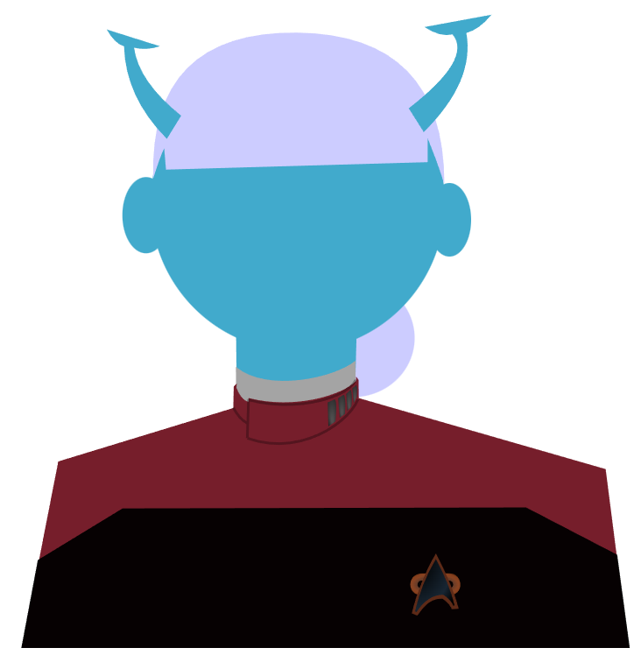
Sh’Aielenza runs a tight ship, but knows the importance of bonding and life outside working. She likes to fully commit to a bit or a task. Not too proud to run the ship if the captain wants to join an away team here and there. Has a large family back home who call all the time.

Role: Executive Officer
Traits: Andoian, Starfleet Officer
Age: 42
Values:
- A busy body thrives in life.
- I would lay my life for a fellow Starfleet soul.
- There’s nothing like seeing it for yourself.
- I don’t trust Romulans and their culture of secrets.
Focuses: Subspace Communications, Long Distance Targets, Small Craft, Team Leadership, Galactic Politics, Fast Decision-Making
Pastime: Parrises Squares
Stress (9): ❑❑❑❑❑❑❑❑❑

Attributes
Control | 9 | Fitness | 9 | Presence | 10
Daring | 12 | Insight | 9 | Reason | 7

Departments
Command | 5 | Engineering | 1 | Medicine | 3
Conn | 2 | Security | 3 | Science | 2

Attacks
Unarmed Strike
Melee, Stun 2, Intense, 1H
Phaser Type 1E
Ranged, Stun 4 / Deadly 3, 1H, Charge

Abilities & Talents:
- Intense (Species ability): 2e Core Rulebook page 100. When Sh’Aielenza uses threat to buy dice and wins, she gets a bonus momentum for each die bought.
- No Pain, No Gain: 2e Core Rulebook page 150.
- Bold (Security): 2e Core Rulebook page 149.
- Proud and Honorable (Andorian Talent): 2e Core Rulebook page 151.
- Coordinated Efforts: 2e Core Rulebook page 157.
- Executive Officer (Role Ability): 2e Core Rulebook page 135

Commander Christopher Ellis
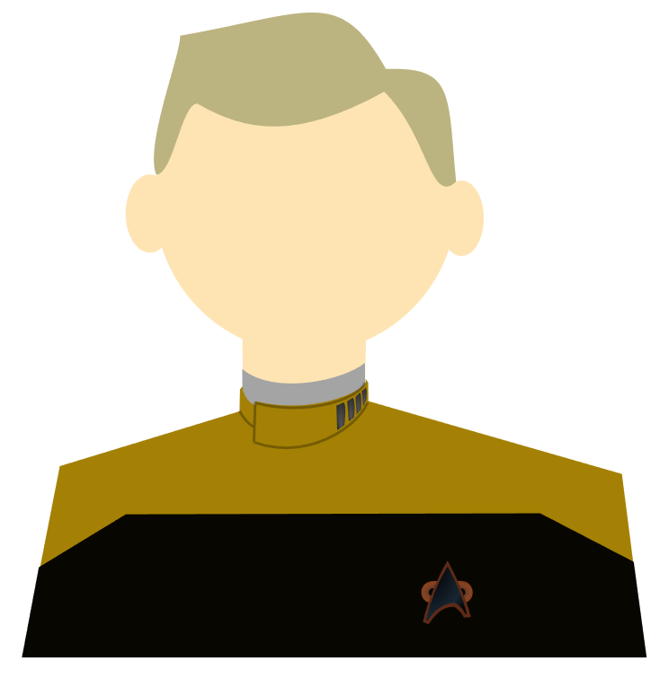
Ellis likes his quiet, whether that’s in the Gardens or his Warp Core humming along efficiently. He encourages all of his staff and friends to try new experiences and keep a hobby.

Role: Chief Engineer
Traits: Human, Starfleet Officer
Age: 31
Values:
- Humanity is in a new era of its evolution, and I embrace it.
- Measure twice and cut once.
- I won’t let doubts get in the way of doing what needs doing.
- Sometimes, the real solution to a seemingly technical problem is just getting people to talk it out.
Focuses: Music Theory, EPS Systems, Transporters & Replicators, Survival, Cybernetics, Ancient Technology
Pastime: Illustration
Stress (7): ❑❑❑❑❑❑❑

Attributes
Control | 11 | Fitness | 7 | Presence | 10
Daring | 7 | Insight | 11 | Reason | 10

Departments
Command | 4 | Engineering | 5 | Medicine | 2
Conn | 2 | Security | 2 | Science | 1

Attacks
Unarmed Strike
Melee, Stun 2, Intense, 1H
Phaser Type 1E
Ranged, Stun 4 / Deadly 3, 1H, Charge

Abilities & Talents:
- Faith of the Heart (Species Ability): 2e Core Rulebook page 107. When Ellis uses Determination, gain 1 momentum.
- Spirit of Discovery (Human Talent): 2e Core Rulebook page 152.
- Procedural Compliance: 2e Core Rulebook page 160.
- Saboteur: 2e Core Rulebook page 161.
- Repair Team Leader: 2e Core Rulebook page 161.
- Chief Engineer (Role Benefit): 2e Core Rulebook page 136.

Lieutenant Tau
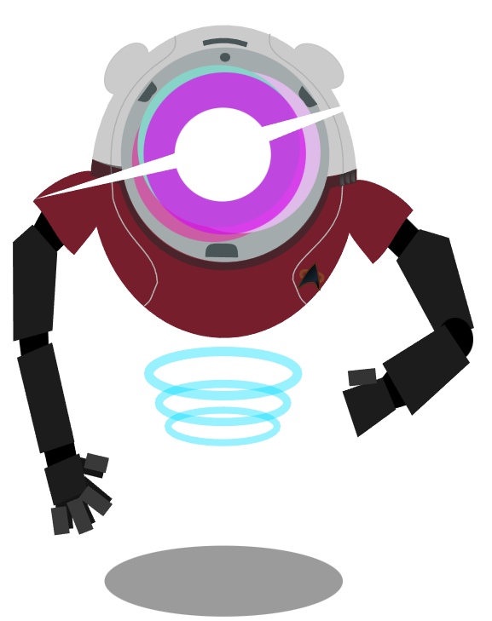
Loves being part of the excitement of Starfleet. Tau is always speculating about the lives of others on new or known planets.

Role: Helmsman
Traits: Medusan, Starfleet Crew
Age: 27
Values:
- I need to know what’s out there!
- Blending into a culture is the best way for me to be accepted.
- Peaceful places and peoples need to be protected from aggressors.
- I can pilot anything.
Focuses: Astronavigation, Fluid Dynamics, Flight Patterns, Forensics, Stealth Tactics, Emergency Medicine, Etiquette
Pastime: Holodeck RPGs
Stress (10): ❑❑❑❑❑❑❑❑❑❑

Attributes
Control | 10 | Fitness | 10 | Presence | 8
Daring | 11 | Insight | 9 | Reason | 8

Departments
Command | 1 | Engineering | 1 | Medicine | 3
Conn | 5 | Security | 2 | Science | 4

Attacks
Unarmed Strike
Melee, Stun 2, Intense, 1H
Phaser Type 1E
Ranged, Stun 4 / Deadly 3, 1H, Charge

Abilities & Talents:
- Telepathic (Species Ability): See the Telepathy talent in the 2e Core Rulebook, page 156.
- Uncanny Navigation: See earlier in this book. Whenever tau is performing a Conn task that would involve the ship, they may forgo the ship’s assistance in exchange for the first extra die, set to one.
- Spacewalk: 2e Core Rulebook page 159.
- Visit Every Star: 2e Core Rulebook page 159.
- Zero G Combat: 2e Core Rulebook page 159.
- Flight Controller (Role Benefit): 2e Core Rulebook page 137.

Lieutenant Scylla
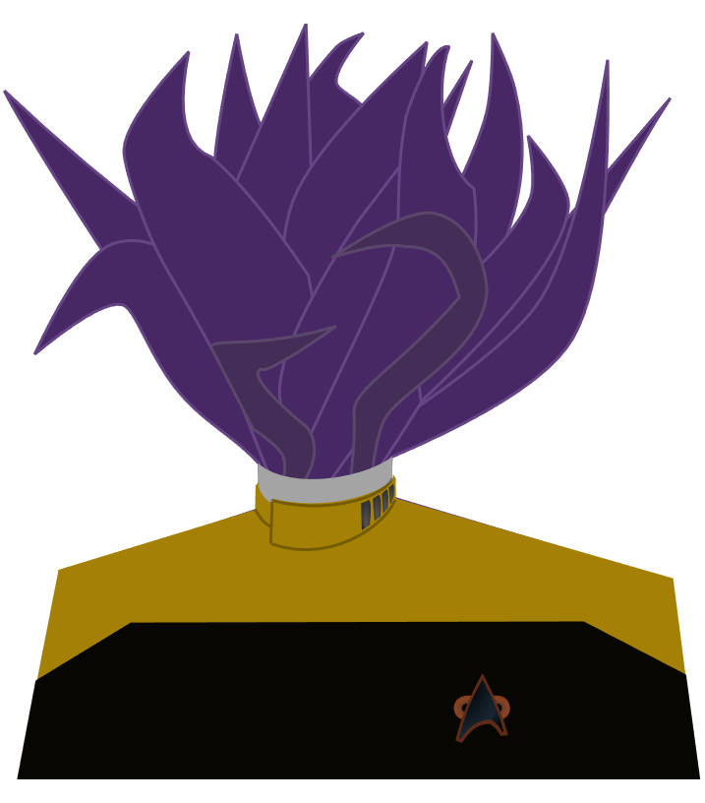
A gentle soul, they are always there to listen to a friend or to join in when a group needs just one more player. They particularly like celebrating crew birthdays.

Role: Operations Manager
Traits: Sukhabelan, Starfleet Officer
Age: 38
Values:
- Having even one ally means the world to people.
- Official guides and policies are comprehensive enough to cover most situations, but few read it all.
- It’s wise to have a defense against all possible threats, even allies.
- Cultures have the right to decide their own destinies.
Focuses: Squeeze into Spaces, Natural Resources (such as minerals), Hand-to-Hand Combat, Starfleet Protocol, Starship Phasers, Spacewalking, Composure
Pastime: Playing Drums
Stress (10): ❑❑❑❑❑❑❑❑❑❑

Attributes
Control | 8 | Fitness | 10 | Presence | 11
Daring | 12 | Insight | 8 | Reason | 7

Departments
Command | 4 | Engineering | 2 | Medicine | 2
Conn | 2 | Security | 5 | Science | 1

Attacks
Unarmed Strike
Melee, Stun 2, Intense, 1H
Phaser Type 1E
Ranged, Stun 4 / Deadly 3, 1H, Charge

Abilities & Talents:
- Narrow Passage (Species Ability): See species earlier in this book. Tau has the focus Squeeze into Spaces, gains two momentum on any scene where they’re trapped or confined.
- Collaboration (Security): 2e Core Rulebook page 149.
- Get Down!: 2e Core Rulebook page 161.
- Lead investigator: 2e Core Rulebook page 162.
- Mean Right Hook: 2e Core Rulebook page 162.
- Chief of Security (Role Benefit): 2e Core Rulebook page 1

Fenchurch Olive Petra of the Dawn Glow


The crew’s local guide to the region, here to ensure we don’t get in over our heads or stumble into any obvious troubles. She’s spent years strengthening relations in the SCIP. Wise and willing to make friends.

Role: Ambassador
Traits: Chita-Delvan, Diplomat
Age: 53
Values:
- Societies must grow and adapt.
- Never fully trust a group of telepaths or a hive mind.
- The strength of the Confederation is important for Sarell’s stability.
- I will not let anyone die on my watch.
Focuses: Linguistics, Cultural Studies, Music, Politics, History, Diplomacy, Traps, Food and Water Sources,
Pastime: Playing Wind Instruments
Stress (14): ❑❑❑❑❑❑❑❑❑❑❑❑❑❑
Attributes
Control | 8 | Fitness | 12 | Presence | 8
Daring | 9 | Insight | 10 | Reason | 9

Departments
Command | 4 | Engineering | 2 | Medicine | 3
Conn | 3 | Security | 2 | Science | 2

Attacks
Unarmed Strike
Melee, Stun 2, Intense, 1H
Phaser Type 1E
Ranged, Stun 4 / Deadly 3, 1H, Charge

Abilities & Talents:
- Social Mirror (Species Ability): See species earlier in this book.
- Studious: 2e Core Rulebook page 150.
- Tough: 2e Core Rulebook page 150.
- Testing a Theory: 2e Core Rulebook page 163.
- Walking Encyclopedia: 2e Core Rulebook page 164.
- Veteran (Experience Talent): 2e Core Rulebook page 128.
- Political Liaison (Role Benefit): 2e Core Rulebook page 139.

Story
Players must first head towards their first directive — to further investigate the lost colony, and clean up remaining technology. There will be a few missions prior to reaching it from the starbase. A “ghost town” will appear on a planet in one of these missions, the crew must investigate.

Then, players will be free to explore the regions, each has a series of missions designed for exploration of the area. They should make their way to at least 2 of the 3 “disappearance clue” planets, Tol, Hexeract, and Re’ath’el. Game masters should feel free to move the players along to other regions when they’ve run through all the missions in an area or you want to pick up the pace.

Players will encounter a dyson vine around a star, after some treacherous subspace disturbance and spacetime tears that threaten the ability to warp. They must investigate the dyson vine. There is a planet around the star whose population suffered an apocalypse due to the recent (a year ago) appearance of the dyson vine. That planet is an option if the players don’t immediately think to land on the vine. When on the vine, they will find only vibrant plant life and an eldritch consciousness of the dyson vine itself.

Afterwards, Starfleet will ask the crew to investigate reports of themselves. Another identical ship with the exact same crew has been doing good will missions. A timeline split was caused by a rip in spacetime we passed. The crew is in the middle of a hostile borg takeover when encountered. Too much of the ship is compromised, so it will need to be destroyed.

Fit in any last missions you want them to have.

The crew is made aware of an even larger dyson vine, travelling through the region and swallowing planets in its path. It must be stopped. Regional fleets try and are unable to destroy or nudge it. Starfleet vessels that get close are fired upon by lifesigns on the plant itself. There must be a weakness or way to stop it.

The following pages contain Mission Briefs to help run this overall story:

Mission 1: Welcome to the Expanse
“We’ve arrived at Starbase 418 as of 2200 hours. After a good night’s rest, the crew is excited to stretch their legs and familiarize themselves with our base of operations for the next year or so. The senior staff and I will be meeting the station’s commander Frank Haskins, and then introduced to Admiral T'Vel and the [ship name]’s new guest, the local Confederation ambassador. We have much to do now that we’ve finally arrived in the Expanse.”

Synopsis
One or more of the senior staff should show off the ship. All other players, role play enjoying your past times.

Directives
- Don’t let the ambassador come to any harm.
- Show the Federation and Starfleet in a positive light.

Focus
Players should create and experience their own ships first-hand. It’s also an opportunity to explore the mundane aspects of life in space, your hobbies, the third spaces aboard the ship and maybe even the station.

Major Beats
A tour of the ship before exhausting Ambassador Fenchurch:
Extended Task | Attr | Dept | Track | D | R | Breakthroughs
Tour Ship | Presence | Command | 12 | 2 | 1 | 50%) -1 Resist | 75%) -1 Difficulty

Minor Beats
A holodeck sports game, a concert, a holiday in the ship’s arboretum, etc.
A series of situations could affect the crew or the tour. Roll at the start of each scene.
Minor Events
1 - 2 | Officer shows up late to shift | 11 - 14 | Environmental controls glitch
3 - 6 | EPS overload causes malfunction | 15 - 18 | Anomaly hits the ship
7 - 10 | Unexpected level 4 diagnostic shuts down something you expected to work | 19 - 20 | Ensign causes a system to malfunction dangerously

Mission 2: The Aurora Caverns
“Our science officers are given an exciting look at the Yil’s cave aurora: a beautiful event due to their caverns’ natural minerals interacting with a charged atmosphere.”

Synopsis
Mission to document an “underground arora” with Yil folk. The cavern caves in from violent weather.

Directives
- Capture data from the subterranean aurora
- Respect locals and their customs
- Offer aid whenever needed.

Focus
Science officers should be gathering data, medical staff tending to the wounded, and command officers helping to organize rescue missions and resolving disputes.

Major Beats
We visit the Yil, who need sunglasses to view the event, but is safe for our eyes.

The aurora is more intense than it should be; due to an ion storm and hurricane rolling in. Flooding and danger everywhere. Some folks will be stubborn and wish to be completely on their own - it is a well-known sub-cultural thing and must, unfortunately, be respected. Others band together, and we must aid those efforts.

The crew may either help the Yil wait the storm out, utilize pattern enhancers to cut through beaming interference, or engineer some storm protection above or within the caves to direct the water elsewhere. Perhaps there is already some storm protection that isn’t working that needs repairs.

Minor Beats
- Early on, many rolls, difficulty 0 or 1, but prepare for and recommend many Obtain Information spends
  - Control + Science to learn about native fauna and fungi, or the aurora
  - Insight + Engineering to learn about their incredible urban infrastructure
- Social Conflict when officers ignore the hermitage sub-culture individuals and try to help anyway.

Mission 3a: Spectacular Shutdown
“The crew is pointed to an in-progress stellar event, where a nebula is about to have a multi-coalescence event, resulting in hundreds of near-simultaneous supernovae creating a stellar nursery. Such a thing has only been theorized and supposedly observed from afar. On route, the whole crew has been working hard on hundreds of individual projects, utilizing the new short-throw holography of our new commbadges.”

Synopsis
Mission to observe stellar phenomena, the ship’s systems are affected by a cascading malfunction after trying to process too many requests simultaneously. The crew needs to isolate and reboot the ship’s computer systems.

Directives
- Survive the stellar onslaught
- Restore power to the ship.

Focus
Command must organize the crew in a low-comms environment. Engineering is the star department overall.

Major Beats
Have each player describe a work project they’re busy with. Then, there is a one-in-a-million computer overload cascade which shuts down all computers and makes the commbadges useless.

The crew, particularly engineering, are required to perform a gated challenge to first get back to “gray mode” and then to get the shields up. These challenges will require these activities to happen in multiple areas across the ship, so Fitness challenges or creative solutions to the lack of powered comms.

Minor Beats
Players could be trapped in a turbolift or behind a particularly heavy door cargo bay where manual override is not an option, so they need to escape through the jeffrey’s tubes.

Someone could be badly hurt, and a doctor needs to go “back to basics” with only a no-database tricorder, tourniquets, and already-handy hypospays (spend momentum and explain why you already had them prepared).

Mission 3b: Shadows of the Past
“We’ve received some kind of distress signal from the city of Kitezh on a planet not marked as populated on any maps we have access to. I’m preparing for first contact.”

Synopsis
A planet shows a massive metropolis, Kitezh, under siege from Na’kuhl temporal war agents.

Directives
- Protect the residents from Temporal Agents
- Find a way to fix the intermittent nature of the city.

Focus
Science and Command officers should be struggling against both temporal mechanics and ethics. Engineers may come up with defenses and detection tools alongside science.

Refer to
NPCs and Starships for the Na’kuhl.

Major Beats
Players will find a city on scan radiating massive chroniton radiation. If they use ‘Obtain Information’ or scan specifically for it, they will discover that the whole area is flipping between two possible timelines.

On the ground, the president of their people pleads for help. He will point to a massive power plant in the central district which powers everything where hostiles are if players don't scan and find them themselves.

Throw one Na’kuhl temporal agent at them, just to tease and acclimate players to fighting against temporal grenades.

The PCs need to visit the power station and either shut it all down completely or stop the Na’kuhl from setting up the feedback overload device which will erase the planet’s population. Here, throw at least one temporary agent per PC and spend threat as desired to increase the enemies in combat. If there are PC storylines in orbit, the Na’kuhl ship could arrive and cause trouble for enough threat.

Minor Beats
When beaming down, PCs might have become lost in the other timeline where the population is gone. If so, set up a ticking countdown for when the city will switch again, and give them beasts to fight.

Mission 4: The Ghost Town
“We’ve arrived at the known site of the lost federation colony, Roanoke. Readings don’t show signs of anyone left, but on the ground, the hairs on my neck are standing.”

Synopsis
Mission to investigate the abandoned Federation colony site. There seems to be signs of life and evidence of violent struggle. When the lifeforms turn out to be scavengers looking for medicine, a journey through an abandoned care center makes everyone paranoid.

Directives
- Discover the fate of the colonists
- Render aid to all who ask.

Focus
Security and command take point in the investigations and safety of the crew. Science analyses the clues. Medical officers aid us in the conclusions.

Major Beats
A small town of 500 colonists, 200 houses, solar farms, agricultural engineering warehouses, a dozen civic administration buildings in the center of town by a town square with an abstract kinetic statue in the center. A very small med-center is in the middle of town, but a much larger medical care center sits outside of town on a hill.

Players should explore the town, be given a description of a pretty comfortable living experience for colonialists, where most folks live with minimal personal belongings, but enough to be telling of who they were. Perhaps many notebooks for a writer, a spinning wheel and knitting basket for someone who had a fiber art hobby, a garage full of hover-bike parts.

The crew should at some point feel like they’re being watched, find evidence of a violent struggle and an unusually-fast overgrowth of wines. But it is hard, not impossible, to scan for the lifeform. All roads should lead them to the care center.

The center was taking care of those in society who need extra special - mental or medical - treatment, temporarily and permanently. All signs are that people were taken care of nicely, ethically but it’s abandoned, large, and liminal now.

When they find the survivor, it’s clear he’s extra paranoid and it only got worse without any help around. He panicked and hid his lifesigns when the invaders arrived, and he can describe them in fleeting detail: plant-folk, borg, and hooded figures. You’re not sure what to believe due to his mental state - rescue him.

Mission 5a: A Tol Tale
“The crew has been invited to Tol Major, spiritual home for one of the big religions in the Expanse, to play a game of… for lack of a better descriptor, golf.”

Synopsis
Important religious center Tol Major invites the crew to a golf tournament as a friendly way of getting to know each other. But at night, the crew hears whispers in the dark.

1
2
3
4
5
6

Directives
- Keep cordial relations with the Tollans, avoid offending them.
- Do well to impress in the game.
- Find any Roanoke mystery clues.

Focus
Players should find ways their skills can translate into ability at the sport. Telepaths will be shocked at the amount of “heathen” and “eventual conversion” thoughts going through their heads.

Major Beats
PCs beam down and meet the Holy Emperor and their tournament competitors. They have selected three of their best. You can have as many players as choose to, at least two, participate.

PCs should go through a few holes, say 5 to 9, as the ‘front half’ the first day, and just as many the next for the ‘back half’. Clearly state the obstacles and distances. Fitness & Conn rolls for distance, Control & Conn rolls for trick shots. Difficulty should be 1 or 2 but with Complication Ranges starting at 2, spend Threat to add windy condition trait potency. Don’t force the golf challenge to get in the way of any other hijinks the PCs want to get up to.

Minor Beats
Ahlen extremists should target one of the players, be trying to poison and kidnap them for ritual sacrifice at a nearby volcano. At night, they will look like the classic hooded cultist archetype. The PCs might try to discover who among their hosts is a cultist, but to falsely accuse or accuse without proof would be a diplomatic disaster!

Mission 5b: Two Roads Diverged
“It’s been a few years since any Starfleet captain has seriously had to be worried about the Borg. I am unfortunately heading into the belly of the beast under orders to learn what level of threat this collective poses.”

Synopsis
The Borg of Hexeract are a ghost story in the Sarell Expanse. They are a very real and very different group of Borg: no nanobots, no queen, no connection to the rest.

Directives
- Avoid assimilation of Starfleet.
- Avoid direct confrontation.
- Download as much of their database as possible.
- Find any Roanoke mystery clues.

Focus
Engineering and Security.

See
NPCs and Starships for Queenless Borg.

Major Beats
The crew nears Q.L. Borg territory. There are Borg Cubes patrolling the region, a tall rectangular prism space station, and further in, the planet Hexeract. Players should decide which they intend to beam or fly over to, and what their plans are. All scans suggest these Borg are similar to those first encountered by the Enterprise D way back in 2365 (Stardate 42761).

The crew should want to remain hidden, access the computers, and download as much data as possible before escaping. The download itself is an extended Task, and will put the Borg on Alert I, at each breakthrough, increase the Alert Trait’s potency by 1. Roll each turn to see if drones show up in their area, let the PCs know, then the drones should do an Insight + Security. Difficulty 4 minus the Alert level.

Extended Task | Attr | Dept | Track | D | R | Breakthroughs
Download Data | Control | Engineering | 12 | 2 | 1 | 50%) -1 Resist | 75%) -1 Difficulty

Minor Beats
Borg of Chita-Delvan or Chita-Gorvan origin are present as workers and light combat, as will there be Yil drones in the lower levels attending to engineering tasks. Hirogen drones will appear only at an “Alert III” as heavy-hitting combat drones.

Ensure there are no-name “red shirt” crew alongside the NPCs, so that combat and abduction for assimilation is a real threat.

Mission 5c: Shore Leaving
“We’ve all been working hard and it’s been some time since we’ve had a break. So, while a few of us are still pondering the clues from the Roanoke disaster, we’ve let most of the crew out on shore leave. Re’ath’el is apparently known as a hub of relaxation.”

Synopsis
Protectorate planet Re’ath’el is connected to its moons by a giant “Motherplant” which gives the residents a mild form of spore-based telepathy. It is also a place of leisure. The crew is here both to learn and take a little shore leave too. Some young Chlomorii try to take the ship while we’re away.

Directives
- Make a good impression with this SCIP member race.
- Find any Roanoke mystery clues.

Focus
Command and security will take charge in the “main” plot. Personal focus otherwise for the rest.

Major Beats
The PCs land, and while many go off to shore leave, a core group will fly down and meet with the “Prime”, Shah. She will entreat them to see their largest city by floating leaf transit. The crew should ask her any questions about them as possible and go out onto the town to find “hard workers” in the central district open for 3 hours after sunset to make large quantities of food for everyone to feast on. There’s little in the way of industry, but there are many bookstores and arcades.

When there’s been enough time, or if someone attempts to contact the ship, they will be unable to. They will need to fly back and board their own ship to discover it’s being taken over. You can spend Threat to prevent them from using the docking bay and make them enter via bulkheads/airlocks.

A pirate crew of seedling Chlomorii have brought old hacking devices from independent Romulan agents and a massive motherplant “cutting” to help them bypass and override the ship’s systems. Take the ship back by direct force or by stealth. These are punk kids from a friendly world, so take them alive if possible.

Minor Beats
Take the time to really explore what your PCs enjoy in their personal time, whether they enjoy shore leave, and who they are. The planet and more so its moons have a variety of natural wonders, breathtaking sites, challenging climbs, deep bioluminescing spelunking, and some plain ol’ intergalactic resorts.

Mission 6: Statues in the Dark
“We have discovered an astronomically-large jungle encircling a star near-completely, like a natural Dyson sphere. It’s a rare phenomenon we must study.”

Synopsis
The crew discovers a cosmozoan jungle which devoured the star and killed a whole solar system of its life. Another ship enters the system, attacks it and heads to one of the planets. The crew will discover both solidified and animated “Sarwai” on planets near the dyson vine and far from it.

Directives
- Observe and learn about this rare phenomenon.
- Seek out new life and new civilizations.

Focus
Science officers should take the forefront here. Command or Security might act as well.

Major Beats
The PCs ship has just entered the system: give them some time to discover the Dyson Vine, observe its similarities to the Motherplant of Re’ath’el. Another ship will enter the system, fire a volley of torpedoes at the plant, which opens a small hole shining faintly onto the system. Scans show it is immediately healing, and will re-close in a few days. They will ignore hails and head straight for the fourth planet in the system, where ruins seemingly only a hundred years old stand of a once-thriving metropolis. There are ruins on the fifth planet as well. You may choose to explore either at this point.

Once on a planet, you will discover the “Sarwai”, first as statues and then a living, awake one. Players will be naturally led by the rubble and sounds/scans towards an abandoned art museum full of statues and paintings. That lonely one Sarwai will be enraged and may attack the crew. If you respond with hostility in kind, it will attempt to surround you and the caustic nature of its being will burn and harm you. The angrier it is, the more its ooze eats away at the surroundings. Attempts to communicate with it, dance or sing, will calm it down. If hostilities go on for too long, there will be a whole dozen Sarwai from outside that enter and calm the “groggy” ones for you.

Minor Beats
If you attempt to say hello to the visiting aliens called “Pompeians”, there are two things: they have no idea about the Sarwai, and this used to be their ancestral home before the Dyson Vine arrived and destroyed the star of their home planet, forcing everyone to relocate to their people’s far-off colonies before they were truly ready to.

Mission 7: An Echo Too Many
“Starfleet has asked us to investigate reports of… our ship doing goodwill missions we’ve never reported doing. We suspect copycats and are tracking them now.”

Synopsis
Investigate do-good doppelgangers. A timeline split was caused by a rip in spacetime you passed. The crew is in the middle of a hostile borg takeover when encountered. Too much of the ship is compromised, so it will need to be destroyed.

Directives
- Prevent the assimilation of Starfleet technology.

Focus
Security and command will need to act on this ethical dilemma.

Major Beats
Follow the warp signature of your own ship northward to the expanse’s “northwest” region. You should have to make a few hops, where you might encounter a small ship which hails you, thanks you “again” and asks if you forgot something. If you ask, “you” helped them recover an important cultural artifact from thieves while helping the captain rediscover the meaning of family.

When you eventually make a jump to where the doppelgangers haven’t moved on, but there is a wrecked and a nearly-disabled Borg sphere and a tractor beam holding another version of your ship. Scans show the whole ship is deep in the process of takeover and the crew is being abducted and surgically altered. The process is pretty far along.

Your players might debate what to do, remind them of the directive and the ticking clock. If they’re going to rescue someone, they need to do it fast and then destroy both ships to keep modern Starfleet tech out of the hands of the Queenless Borg.

Minor Beats
If you asked the strangers for help, or informed them of the situation, it’s possible at least one will come along and complicate matters trying to help “you” back.

Mission 8a: The Grahk Squad
“Starbase 418 has found themselves overrun by a nest of flying creatures that are hard to detect and invisible to the eye. We’re picking up a group of legendary Chita-Gorvan hunters, known as the Grahk Squad, to help us track them down and remove them.”

Synopsis
A species of invisible bats have been breeding on the station for months. The invasive species is starting to interfere with daily life, so the crew teams up with “the Grahk Squad”, bring them to the station and help them capture if possible, though they prefer to exterminate.

Directives
- Respect life as much as possible.
- Get them out of here!

Refer to
NPCs and Starbase 418 itself.

Major Beats
Players may not have truly explored the station on prior missions, so now is a good time to gear up at the pavilion’s shops. The squad should suggest scanning both the civilian engineering bays and the gardens in the lower ring, perhaps the party splits up to search faster.

You’ll eventually find their nest, roosting above the antimatter processing tanks in the lower engineering sections. It’s hot and steamy and difficult to navigate spaces.

Minor Beats
Create some civilian vendors for the pavillion, interesting characters maybe as callbacks to folks seen on prior visits. The Ferengi are deeply interested in this space, as might be Betazoids, Brikar, or even post-reconstruction Romulans.

Players who don’t wish to be part of the hunt might find themselves helping someone learn about a paramour, in the style of Cyrano de Bergerac. Or a fetch quest “can you help me out, I’m looking for a…” like the DS9 classic episode “Treachery, Faith, and the Great River”. Suggestion: asked for a bottle of Vintage Chateau Picard wine, you find someone who knows where to get one… in exchange for a case of self-sealing stem bolts. They tell you there’s a man who walks through the Arboretum every day who oversees the wine lists of many restaurants. This man simply wants a new pet. How you acquire a creature for him to care for is up to you.

Mission 8b: The Trianum Protectorate
“The [other ship, see below] has sent a distress message to us. Seems they’ve played their cards wrong, and are being held prisoner by the Trianum Protectorate. We’re on route to see what’s up and bail them out.”

Synopsis
You are sent to rescue another crew from the far off reaches of the Trianum Protectorate. Defend yourself and play the diplomatic game to ensure everyone makes it home safely. The other crew is being blamed for the sudden onset of a plague.

Directives
- Bring the other crew home
- Smooth over any diplomatic tensions

Focus
Security and command may start out as front-and-center, but it’ll be the Medical officers who can either prove innocence, or cure everyone and prove pure intent.

Major Beats
Their registration is NCC 63404-B. If your hero ship is a Hugo Class, then the other crew flies a Pendragon Class USS Gawain. Otherwise, they’ve a Hugo Class USS Adams.

Aftanosian officials have imprisoned the crew. They await trial for the spread of weaponized contagions. There’s a sickness rapidly spreading through their population.

Instead of an Extended Task, we’ll put the medical PCs (or support characters) through a Gated Challenge. They must scan at least 3 infected from different regions of the planet or city, then perform research and experimentation from at least 2 successful angles ( Daring / Insight / Reason + Medicine Tasks). Once they’ve done all that, they can come up with a hypothesis.

It could be a coincidental outbreak which simply doesn’t affect our crew. It could be a typically-harmless germ which mutated rapidly when in contact with the human microbiome. It could be a sick ensign who decided they wouldn’t let a headcold stop them from seeing a new planet.

Addendum
The Protectorate is intentionally lightly-described so that you may fill in your ideas for what these alien planets are like. Create a city, describe what the Aftanosians look like. A suggestion: a watery paradise and fiery-hot volcano-like titans. Another suggestion: tall, thin aliens on a very low-gravity planet who deflate pathetically when sick.

Mission 8c: Small-Colony Troubles
“In the Gressh system between Re’ath’el and Tarq, there are Chita-Delvan, Chlomorii, and other peoples making new frontier lives for themselves. Except recently, there have been reports of hate crimes and property destruction towards the Chlomorii. The SCIP has asked us to investigate these unsettling issues in their otherwise peaceful union.”

Synopsis
Visit Gressh III and investigate, ask the Chlomorii and other inhabitants what happened. Investigate the Ahlen Church and the conflicts between the average believers and the radical ones. Discover who specifically is responsible and catch them red handed.

Directives
- Help our allies route out intolerance.
See
The Gresshen Shadow Man NPC.

Major Beats
The crew arrives in town, makes their way to a local diner to people watch. They’ll overhear the way some folks talk about plants - getting rid of them, weeding aggressively, putting up screens to keep the pollen away. Bordering on normal and obsessive. News pads available everywhere will describe the police having to investigate the “sisterplant” district again. Chlomorii folk will tell you it's the influence of the “very not chill” Ahlen church.

If you follow a churchgoer or two, or if the characters are around at night, they find a bunch bringing torches into the woods - to perform a bush burning and ritual chanting, all known parts of their practice, and not particularly violent.

If you stake out the “sisterplant” district, you’ll find a beautiful, lush place. And you’ll find the culprits, the waitress from the Diner comes at night to throw cleaning acids and eggs. If you delve further, however, you’ll find that a dark presence is possessing her - summoned and appeased by the cultists in the woods.

You must seek out this presence, a beast in the woods that lives in a cave and feeds on, amplifies, the psychic zeitgeist. The cultists actually “summoned” something!

Minor Beats
Vignettes villagers: farmers and simple-but-modern craftsmen. There’s a harvest festival in a week and folks are setting up for it. Some folks are learning to dance.

Finale Mission: The Dyson Vine
“We’re out Investigating a system near the Tol / SCIP border which seems to be missing its known planets.”

Synopsis
The crew is made aware of an even larger dyson vine, travelling through the region and swallowing planets in its path. It must be stopped. Regional fleets try and are unable to destroy or nudge it. Starfleet vessels that get close are fired upon by lifesigns on the plant itself. There must be a weakness or way to stop it.

Directives
- Find a means to stop or redirect the Dyson seed.
- Protect as much sentient life as possible.
See
NPCs and Starships, Dyson Vine Cult sections, at minimum.

Major Beats
The PCs travel to the “Chenkalli” system, where star charts show two planets, but reports have stated are gone. Players should not already be there, but are travelling there. The ship should flag a massive interstellar object (Dyson Vine seed) it had to avoid - the science officer can do a Control + Science difficulty 4 to try to identify it whilst still flying at warp away from it.

Players can either turn around immediately or first witness the lack of planets and the clear trail of destruction. If reconstructed as it looked a month prior, it’ll be a straight line of missing stuff pointing in the direction of the object (the Dyson Vine seed).

The object’s trajectory will pass through several inhabited systems, including Tarq, and also Starbase 418. The loss of life to this is unacceptable, stopping this thing is the new main Directive.

If you scan the seed, there’s a population of thousands. If you attempt to fire on the Dyson seed, phasers will fire back at you. Any attempted attack or contact will result in attempts by the Dyson cultists to board your ship, either by transporter or by a series of medium-sized shuttles.

The Dyson Vine seed is only travelling at Warp 1, mouth-first. The interior of the “mouth” looks like a tiny molten lining - a near star-energy interior.

If nobody suggests it, have an NPC ask if we should inform Starfleet.

Facts to consider
There are many things your players could do, and many facts that could factor in:

- The Dyson Vine and the Motherplant are extremely related species. The cultists who live there are highly protective and are basically drugged by the plant to do its bidding.

- The cultists living on the Dyson Vine are antithetical to the teachings of Ahl the Orgsordent, and it seems to suggest the origins of the “plants are evil” motifs.

- The Ahlen Church and citizens of Tol would be more than happy to aid in the destruction of the Dyson Vine seed.

- The Dyson Vine cultists are extremely dangerous and are not reasonable. You cannot convince them to leave or to help you change its course.

- Many of the cultists living there witnessed the destruction of many planets, gleefully treating them - inhabited or not - as sacrifices to “the Vine” god.

- The Pompeian people might have more of their chemical weaponry they used on the Dyson Vine witnessed before, which is - despite their ignorance to them - very similar to the composition of the Sarwai.

- If the crew has interacted with any Starfleet Time-Travellers in the past, they might attempt to scan for chronoton radiation to track down and ask for help. This would violate the temporal prime directive, unless the time-travellers have already shown concerns about this sequence of events being slightly different than expected.

- It would take a fleet of ships with tractor beams, not being fired upon, to simply nudge the trajectory.

Aftermath
However your players solve the Motion Picture-level crisis, make sure to have folks from any saved planets, SCIP and/or Ahlen Church representatives all come to Starbase 418 to celebrate (and also mourn with a moment of silence those lost).

NPCs
Stats for enemies and allies that need it.

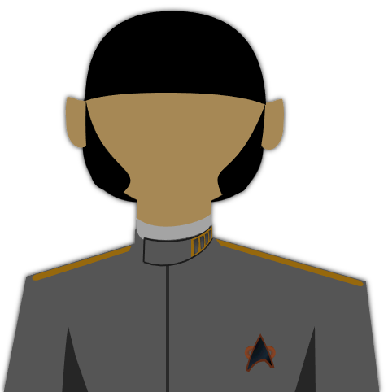
Starfleet

Admiral T’Vel
The admiral wanted to make their mark on history and further the Federation’s exploratory and peaceful spirit. If it wasn’t for the Kolinahr, they’d look like they were having the time of their life.

TRAIT: Vulcan Stress: 9
VALUES:
- The universe is full of fascinating complexity.
- The pursuit of knowledge is the most logical profession.

Attributes
Control 9 Fitness 10 Presence 8
Daring 7 Insight 8 Reason 9

DISCIPLINES
Command 3 Security 1 Science 2
Conn 2 Engineering 1 Medicine 1

Focuses: Rhetoric, Fleet Commander, Coordinating Research Projects, Culinary History

Special Rules / Talents:
- Mental Discipline (see the 2e Core Rulebook, page 113)
- Dauntless (see the 2e Core Rulebook, page 149)
- Calm and Logical (see the 2e Core Rulebook, page 149)
- Kolinahr (see the 2e Core Rulebook, page 154)

Attacks:
- Unarmed Strike: Melee, 1 Stun/Deadly Damage, 1H
- Phaser Type-1: Ranged, 3 Stun/Deadly Damage, Size 1H, Charge, Hidden 1


Commander Frank Haskins
He spent a long time as an engineer and scientist under great captains, and has now mastered his third department well enough to make Admiral. He’s been around and is nobody’s fool.

TRAIT: Human Stress: 11
VALUES:
- Providing a safe home is the kindest thing you can do.
- History is not written yet; we control our fates.

Attributes
Control 9 Fitness 11 Presence 11
Daring 8 Insight 9 Reason 9

DISCIPLINES
Command 5 Security 4 Science 2
Conn 1 Engineering 2 Medicine 1

Focuses: Station Management, Starfleet Protocols, Oration, Gambling

Special Rules / Talents:
- Advisor (see the 2e Core Rulebook, page 156)
- Mercurial (see the 2e Exploration Guide, page 12)
- Protector (see the 2e Exploration Guide, page 13)

Attacks:
- Unarmed Strike: Melee, 4 Stun/Deadly Damage, 1H
- Phaser Type-1: Ranged, 3 Stun/Deadly Damage, Size 1H, Charge, Hidden 1
- Escalation 2 Phaser Type-3: Ranged, 5 Stun/Deadly Damage, Size 1H, Charge


Temporal Agents

Na'kuhl Temporal Agent
Sunken red eyes, grey or beige skin, and harsh facial features. These aliens resemble depictions of vampires from the late 20th and early 21st centuries.

TRAIT: Na’khul Personal Threat: 2 Resistance: 1
VALUES:
- Trample over the past timelines of all others.

Attributes
Control 7 Fitness 9 Presence 7
Daring 10 Insight 7 Reason 8

DISCIPLINES
Command 2 Security 3 Science -
Conn 1 Engineering 2 Medicine 2

Special Rules:
- Tough (see 2e Allies and Adversaries, page 16)

Attacks:
- Unarmed Strike: Melee, 3 Stun/Deadly Damage, 1H
- Force-Field Gauntlets: Melee, 3 Stun Damage, 1H, Accurate, Cumbersome, Hidden 1, Piercing
- Escalation 1 | Na’kuhl Plasma Rifle: Ranged, 4 Deadly Damage, 2H, Debilitating


Tol

Tolan Cultists (Ahlen Extremists)
Taking their belief in their God to a Lovecraftian level of seriousness. They seem like regular Tolan citizens by day, but by night, they’re hooded vessels for the Orgsordent’s will.

TRAIT: Tolan, Ahlen Believer Personal Threat: 0 Protection: 0
VALUE: I serve the Orgsordent and arrange my life to their will.

Attributes
Control 7 Fitness 8 Presence 9
Daring 10 Insight 9 Reason 7

DISCIPLINES
Command 1 Security 3 Science -
Conn 2 Engineering - Medicine 3

Special Rules / Talents:
- Cult Tactics: Their Presence is +1 for each Ahlen cultist nearby over 2

Attacks:
- Unarmed Strike: Melee, 3 Stun/Deadly Damage, 1H
- Akat Blade: Melee, 3 Deadly Damage, 1H, Accurate, Debilitating
- Chitaran Disruptor Pistol, 2 Stun, (2 Escalation) 4 Deadly, 1H, Charge, Accurate


Tolan Golfer
A modern Tolan tip-toeing on the sacreligious, enjoying a hobby which seems to embrace a hobby with lots of plant-life. Don’t misunderstand, to them it’s about showing off their skill on top of a well-controlled landscape.

TRAIT: Human, Ahlen Believer Personal Threat: 0 Protection: 0
VALUE: I believe in having a good time and enjoying life.

Attributes
Control 10 Fitness 9 Presence 7
Daring 8 Insight 8 Reason 8

DISCIPLINES
Command 2 Security 1 Science 1
Conn 4 Engineering 1 Medicine 2

Attacks:
- Unarmed Strike: Melee, 1 Stun/Deadly Damage, 1H


Tolan Pioneer
Taking their people to the stars and settling where no Tolan has gone before. They’re a heartier stock of Tolan, but still are Orgsordent-fearing righteous folk.

TRAIT: Tolan, Ahlen Believer Personal Threat: 0 Protection: 0
VALUE: I wish to expand the reach of my people past their homelands and limits.

Attributes
Control 7 Fitness 10 Presence 8
Daring 10 Insight 8 Reason 8

DISCIPLINES
Command 3 Security 2 Science 2
Conn 3 Engineering 2 Medicine 2

Attacks:
- Unarmed Strike: Melee, 2 Stun/Deadly Damage, 1H
- Chitaran Disruptor Pistol, 2 Stun, (2 Escalation) 4 Deadly, 1H, Charge, Accurate

Queenless Borg of Hexeract
See 2e Allies and Adversaries Sourcebook, pages 37-39, for their main-collective equivalents.

For each,
- remove the “Assimilation” Special Rule, as Queenless collective assimilation is done via kidnapping and slow conversion - nanoprobes which convert quickly are not a part of their tactics.
- Replace “Adaptive Shielding” with this book’s Adaptive Protection (Species Ability)

Borg Adjunct/Medical Drone (Chita-Delvan/Chita-Gorvan)
A Chita-Delvan or Chita-Gorvan, converted by the Queenless Borg collective.

Borg Technical Drone (Yil)
A Yil, converted by the Queenless Borg collective.

Borg Tactical Drone (Hirogen)
A Hirogen, converted by the Queenless Borg collective.

Various Adventure NPCs

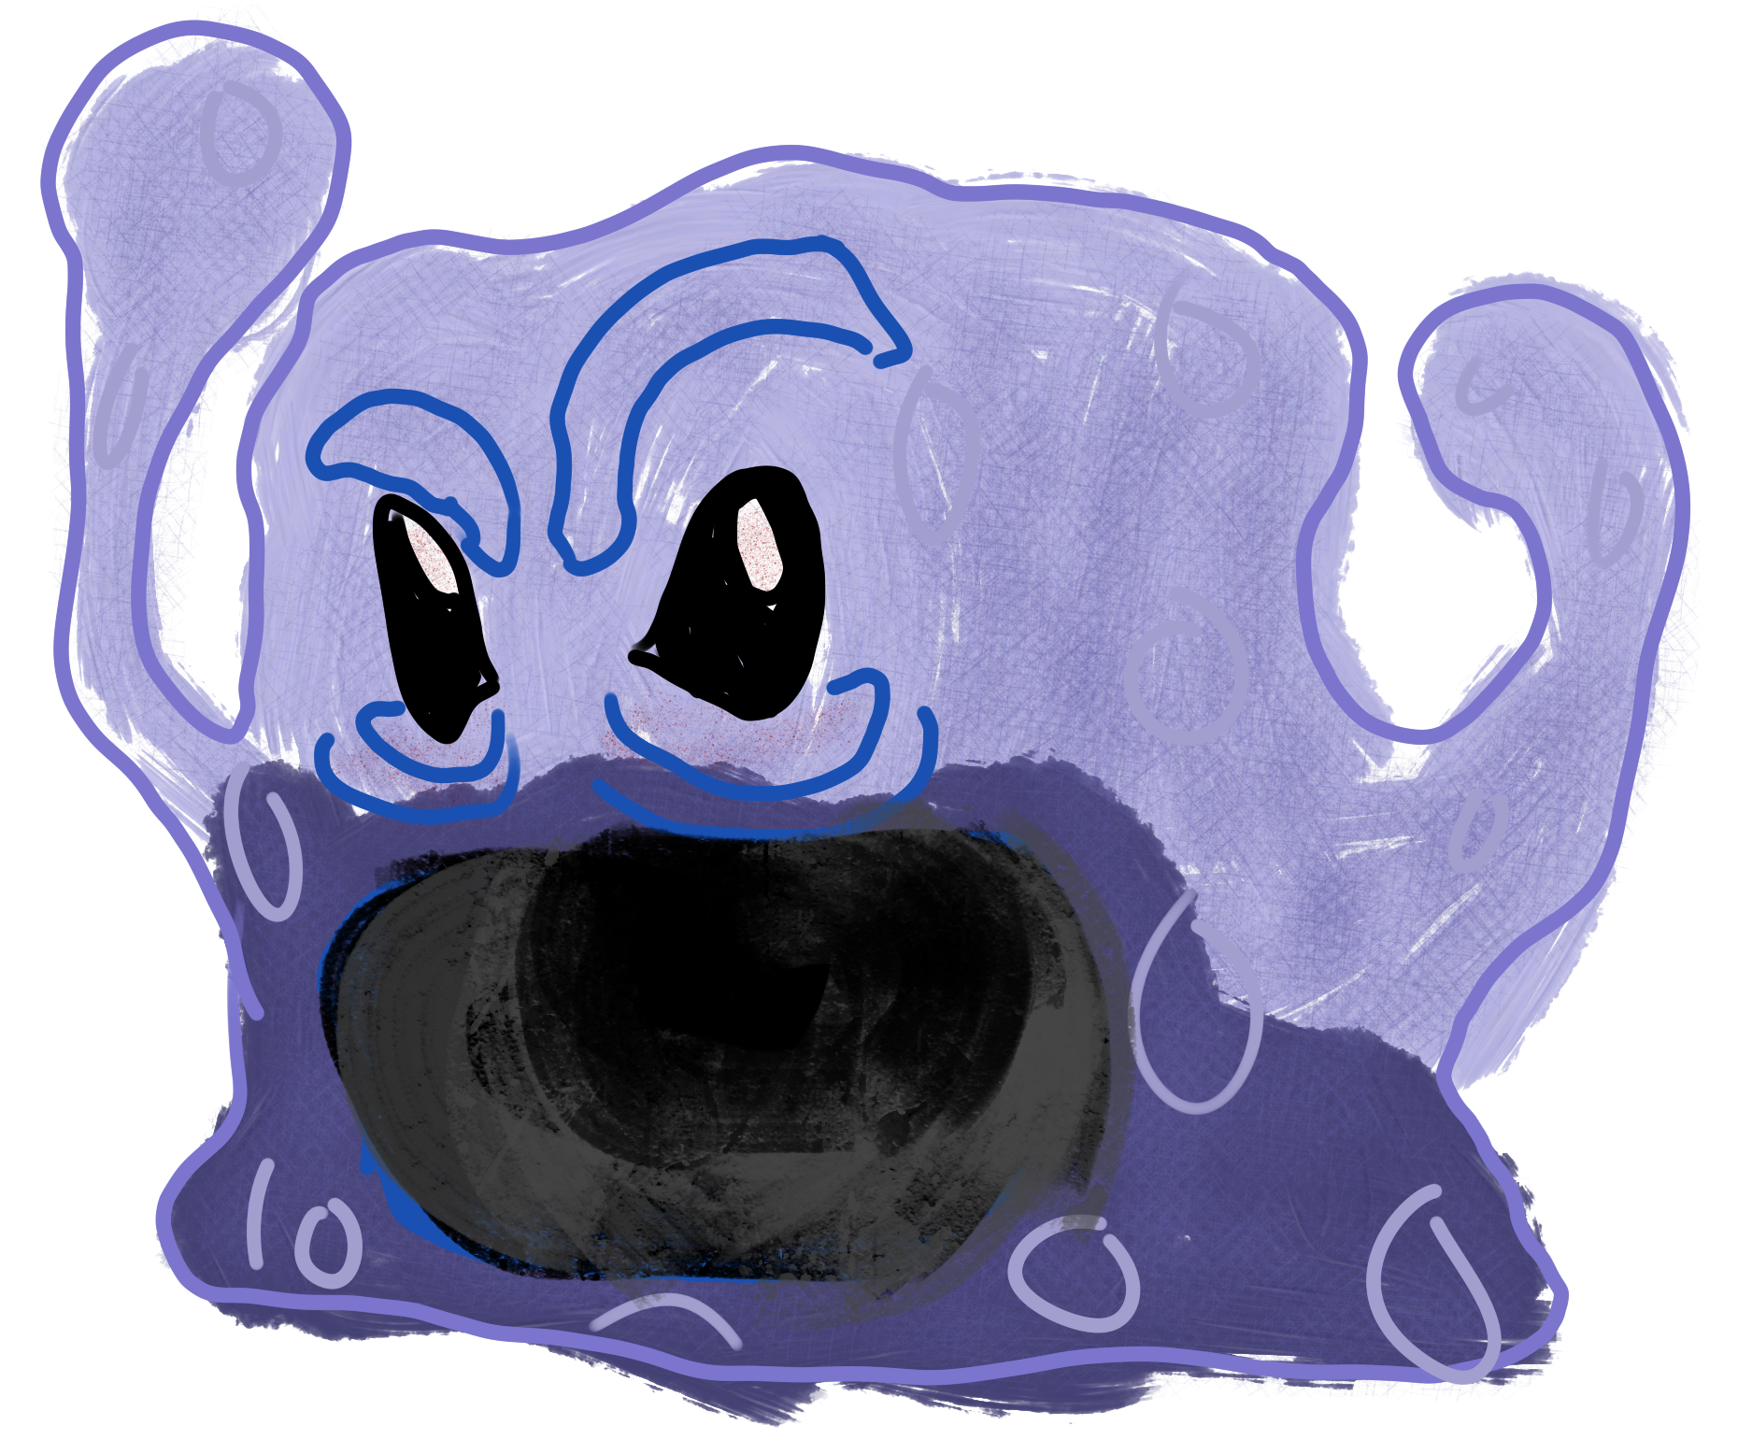
Groggy Sarwai
This poor little… I mean, gigantic guy — is not a morning person. He’s woken up from a protective hibernation and is feeling violently threatened to find you here while it’s waking up. It was a statue of a normal Sarwai only minutes ago.

TRAITS: Sarwai, Groggy
Personal Threat: 6 Protection: 1

VALUE: Protect yourself until you know you are safe.

Attributes
Control 6 Fitness 9 Presence 10
Daring 10 Insight - Reason 6

DISCIPLINES
Command - Security 5 Science -
Conn - Engineering - Medicine 2

Special Rules / Talents:
- Absorbent Consumption (Species Ability)
- Temper-Sized: After every attempt to attack or direct the creature, roll - if the number is even, it grows another few litres of volume. Any intentional, successful attempts to calm it will shrink the creature (to no smaller than a normal Sarwai).

Attacks:
- Unarmed Strike: Melee, 5 Stun/Deadly Damage, 1H
- Shriek: Ranged, 4 Stun Damage, 0H

Pompeian Archaelogist
Just a regular archaeologist trying to do their research without being interrupted.

TRAIT: Pompeian Personal Threat: 0 Protection: 0
VALUES:
- Rediscover the lost histories of your people.
- Any little vengeance on the Dyson Vine is worth doing.

Attributes
Control 7 Fitness 9 Presence 8
Daring 11 Insight 9 Reason 10

DISCIPLINES
Command - Security 2 Science 2
Conn 3 Engineering 1 Medicine 1

Attacks:
- Unarmed Strike: Melee, 2 Stun/Deadly Damage, 1H
- Chitaran Disruptor Pistol, 2 Stun, (2 Escalation) 4 Deadly, 1H, Charge, Accurate

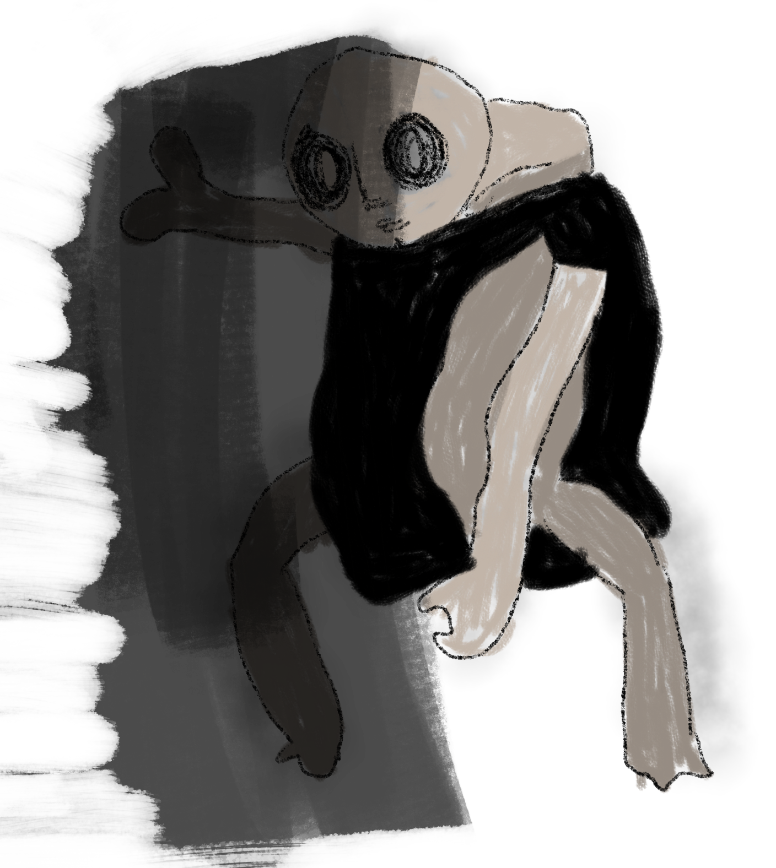
Gresshan Woods Shadow-Man
An unknown danger which must be native to this planet they’ve settled on. It seems to connect with and amplify the desires of those who communicate with it. Maybe it’s only amplifying what it chooses to…

TRAIT: Unknown Entity Personal Threat: 10 Resistance: 6
VALUES: ?

Attributes
Control 7 Fitness 7 Presence 11
Daring 7 Insight 11 Reason 10

DISCIPLINES
Command 5 Security 3 Science -
Conn 5 Engineering - Medicine 2

Special Rules / Talents:
- Shadowy Form: You can spend 2 Threat to instantly move 1 zone, repeatable.

Attacks:
- Unarmed Strike: Melee, 3 Stun/Deadly Damage, 1H
- Shadowy Blade: Melee, 5 Deadly Damage, 1H, Accurate, Debilitating

Dyson Vine Cult

Tolan Dyson Vine Cultist
No longer a servant of Ahl the Orgsordent, but an equally ancient presence… “The Vine”.

TRAIT: Tolan, anti-Ahl, servant of The Vine Personal Threat: 3 Protection: 0
VALUE: Serve, protect, and be near “The Vine”.

Attributes
Control 7 Fitness 8 Presence 9
Daring 11 Insight 9 Reason 5

DISCIPLINES
Command 1 Security 4 Science -
Conn 2 Engineering - Medicine 3

Special Rules / Talents:
- Cult Tactics: Their Presence is +1 for each Vine cultist nearby over 2

Attacks:
- Unarmed Strike: Melee, 4 Stun/Deadly Damage, 1H
- Akat Blade: Melee, 3 Deadly Damage, 1H, Accurate, Debilitating

Chlomorii Dyson Vine Cultist
No longer a child of the “Motherplant”, but a very similar presence… “The Vine”.

TRAIT: Chlomorii, servant of The Vine Personal Threat: 3 Protection: 0
VALUE: Serve, protect, and be near “The Vine”.

Attributes
Control 7 Fitness 6 Presence 10
Daring 11 Insight 11 Reason 5

DISCIPLINES
Command 1 Security 4 Science 3
Conn 3 Engineering - Medicine 3

Special Rules / Talents:
- Cult Tactics: Their Presence is +1 for each Vine cultist nearby over 2

Attacks:
- Unarmed Strike: Melee, 4 Stun/Deadly Damage, 1H
- Akat Blade: Melee, 3 Deadly Damage, 1H, Accurate, Debilitating

Borg Dyson Vine Drone
No longer a drone of the collective, but a very similar hive mind… “The Vine”.

TRAIT: Borg, servant of The Vine Personal Threat: 3 Resistance: 2
VALUE: Serve, protect, and be near “The Vine”.

Attributes
Control 10 Fitness 11 Presence 11
Daring 7 Insight 6 Reason 7

DISCIPLINES
Command - Security 5 Science -
Conn 2 Engineering 5 Medicine 1

Special Rules / Talents:
- Cult Tactics: Their Presence is +1 for each Vine cultist nearby over 2
- Adaptive Protection (see Adaptive Protection (Species Ability) )
- Exoplating (see 2e Allies and Adversaries, page 37)
- Immune to Fear (see 2e Core Rulebook, page 351)
- Immune to Pain (see 2e Core Rulebook, page 351)
- Machine (see 2e Core Rulebook, page 352)
- Night Vision (see 2e Core Rulebook, page 352)
- Threat Protocols (see 2e Allies and Adversaries, page 37)

Attacks:
- Unarmed Strike: Melee, 5 Stun/Deadly Damage, 1H
- Force-Field Gauntlets: Melee, 3 Stun Damage, 1H, Accurate, Cumbersome, Hidden 1, Piercing

Starships
Stats for the various additional ships found in the expanse.

Temporal Agents

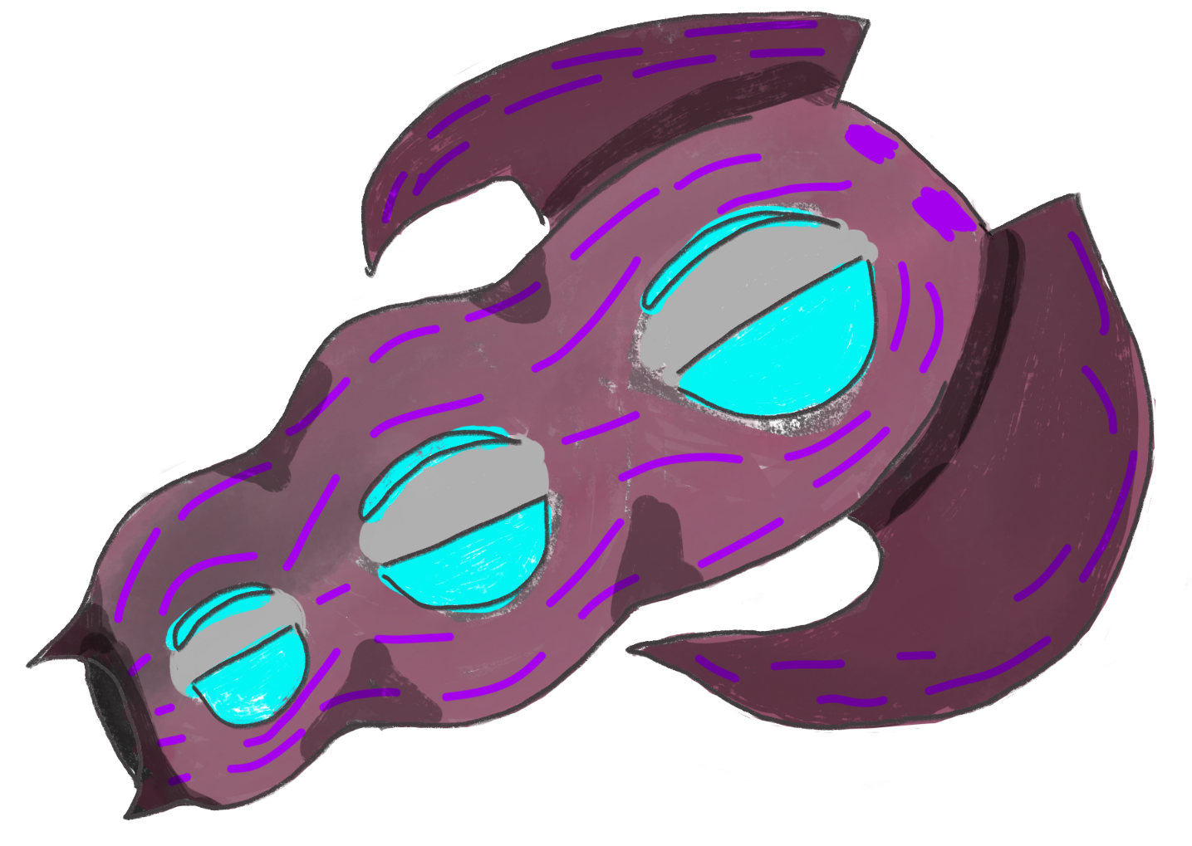
Na’kuhl Timeship
A timeship from a lesser power in the temporal cold wars.

Traits: Na’kuhl, Timeship
Scale: 4 Resistance: 2 Shields: 18

Systems
Comms 9 Engines 9 Structure 11
Computers 10 Sensors 9 Weapons 10

Departments
Command 2 Security 3 Science 3
Conn 3 Engineering 4 Medicine 3

Talents
- Improved Warp Drive (see the 2e Core Rulebook, page 224)
- Improved Impulse Drive (see the 2e Core Rulebook, page 223)
- Regenerative Hull (see the 2e Game Toolkit Booklet, page 29)
- Transport Inhibitors (see the 2e Core Rulebook, page 225)
- Stealth Time Travel: The ship can make a jump back to their own time, but fears of detection from 29th century Starfleet prevent them from making repeated trips back-and-forth.

Attacks
- Energy Draining Weapon: Energy, 4 Damage, Close Range, Dampening
- Quantum Torpedoes: Torpedo, 8 Damage, Long Range, Calibration, Dampening
- Tractor Beam: 4 Strength

Tol

Ahlen Church Warship
A gigantic cathedral in space.

Traits: Tolan, Place of worship, Starship
Scale: 5 Shields: 18

Systems
Comms 11 Engines 9 Structure 11
Computers 9 Sensors 8 Weapons 11

Departments
Command 4 Security 2 Science 1
Conn 2 Engineering 3 Medicine 4

Talents
- Point Defense System (see the 2e Core Rulebook, page 224)
- Command Ship (see the 2e Core Rulebook, page 220)

Attacks
- Photon Arrays: Torpedo, 7 Damage, Medium Range, Versatile, Area or Spread
- Phaser Banks: Energy, Medium, 5 Damage, Versatile 2
- Tractor Beam: 5 Strength

Ahlen Church Cruiser
While it still retains some gothic “church-like” aesthetics, it is much more like a typical starship.

Traits: Tolan, Place of worship, Starship
Scale: 3 Shields: 12

Systems
Comms 9 Engines 10 Structure 8
Computers 8 Sensors 9 Weapons 9

Departments
Command 2 Security 1 Science 1
Conn 4 Engineering 4 Medicine 3

Special Rules:
- Cloaking Device (see the 2e Core Rulebook, page 220)

Attacks:
- Photon Torpedoes: Torpedo, 5 Damage, Long Range, High Yield
- Phaser Banks: Energy, Medium Range, 5 Damage, Versatile 2
- Tractor Beam: 3 Strength

Queenless Borg of Hexeract

Queenless Borg Cube
The main location for the majority of Queenless Borg not on the planet Hexeract.

Traits: Queenless Borg Design, Starship
Scale: 12 Resistance: 4 Shields: 27

Systems
Comms 11 Engines 10 Structure 14
Computers 12 Sensors 10 Weapons 14

Departments
Command 3 Security 3 Science 3
Conn 3 Engineering 3 Medicine 3

Special Rules:
- Colossal: You must create a vulnerability trait in order to destroy a System
- Advanced Transporters (see the 2e Core Rulebook, page 219)
- Regenerative Hull (see the 2e Game Toolkit Booklet, page 29)
- Versatile Tractor Beam (see the 2e Game Toolkit Booklet, page 29)
- Threat Protocols: The Borg ships collectively take as many rounds as the PCs.
- Improved Warp Drive (see the 2e Core Rulebook, page 224)

Attacks:
- Cutting Beam: Energy, 12 Damage, Close Range, Piercing
- Energy Draining Weapon: Energy, 12 Damage, Close Range, Dampening
- Quantum Torpedoes: Torpedo, 8 Damage, Long Range, Calibration, Dampening, High Yield
- Tractor Beam: 7 Strength

Queenless Borg Sphere
A specialty vehicle for Queenless Borg, smaller transport. Many Spheres are converted, after additional resources are acquired, into the cubes for which they serve as oversized escape pods for.

Traits: Queenless Borg Design, Starship
Scale: 4 Resistance: 3 Shields: 16

Systems
Comms 11 Engines 12 Structure 9
Computers 11 Sensors 11 Weapons 8

Departments
Command 3 Security 3 Science 3
Conn 3 Engineering 3 Medicine 3

Special Rules:
- Advanced Transporters (see the 2e Core Rulebook, page 219)
- Regenerative Hull (see the 2e Game Toolkit Booklet, page 29)
- Threat Protocols: The Borg ships collectively take as many rounds as the PCs.
- Improved Warp Drive (see the 2e Core Rulebook, page 224)

Attacks:
- Cutting Beam: Energy, 6 Damage, Close Range, Intense
- Energy Draining Weapon: Energy, 6 Damage, Close Range, Dampening
- Tractor Beam: 3 Strength

Various Adventure NPCs

Expanse Civilian Freightor
A typical runabout-sized ship most civilians will be flying around the Expanse. Especially S.C.I.P. citizens.

Traits: Civilian, Not Polity Specific
Scale: 3 Shields: 10

Systems
Comms 7 Engines 8 Structure 9
Computers 8 Sensors 7 Weapons 7

Departments
Command 2 Security 2 Science 2
Conn 2 Engineering 2 Medicine 2

Special Rules: None
Attacks: None

Pompeian Shuttle
A reworked variant of the classic Expanse Freighter, made by the Pompeians.

Traits: Civilian, Pompeian, Small Craft
Crew: 1 to 5
Scale: 2 Shields: 10

Systems
Comms 6 Engines 10 Structure 8
Computers 8 Sensors 8 Weapons 9

Departments
Command 2 Security 3 Science 4
Conn 4 Engineering 2 Medicine 1

Special Rules:
- Rugged Design (see the 2e Core Rulebook, page 225)

Attacks:
- Phaser Banks: Energy, Medium, 3 Damage, Versatile 2
- Micro-torpedoes: Torpedo, Long, 3 Damage, High Yield

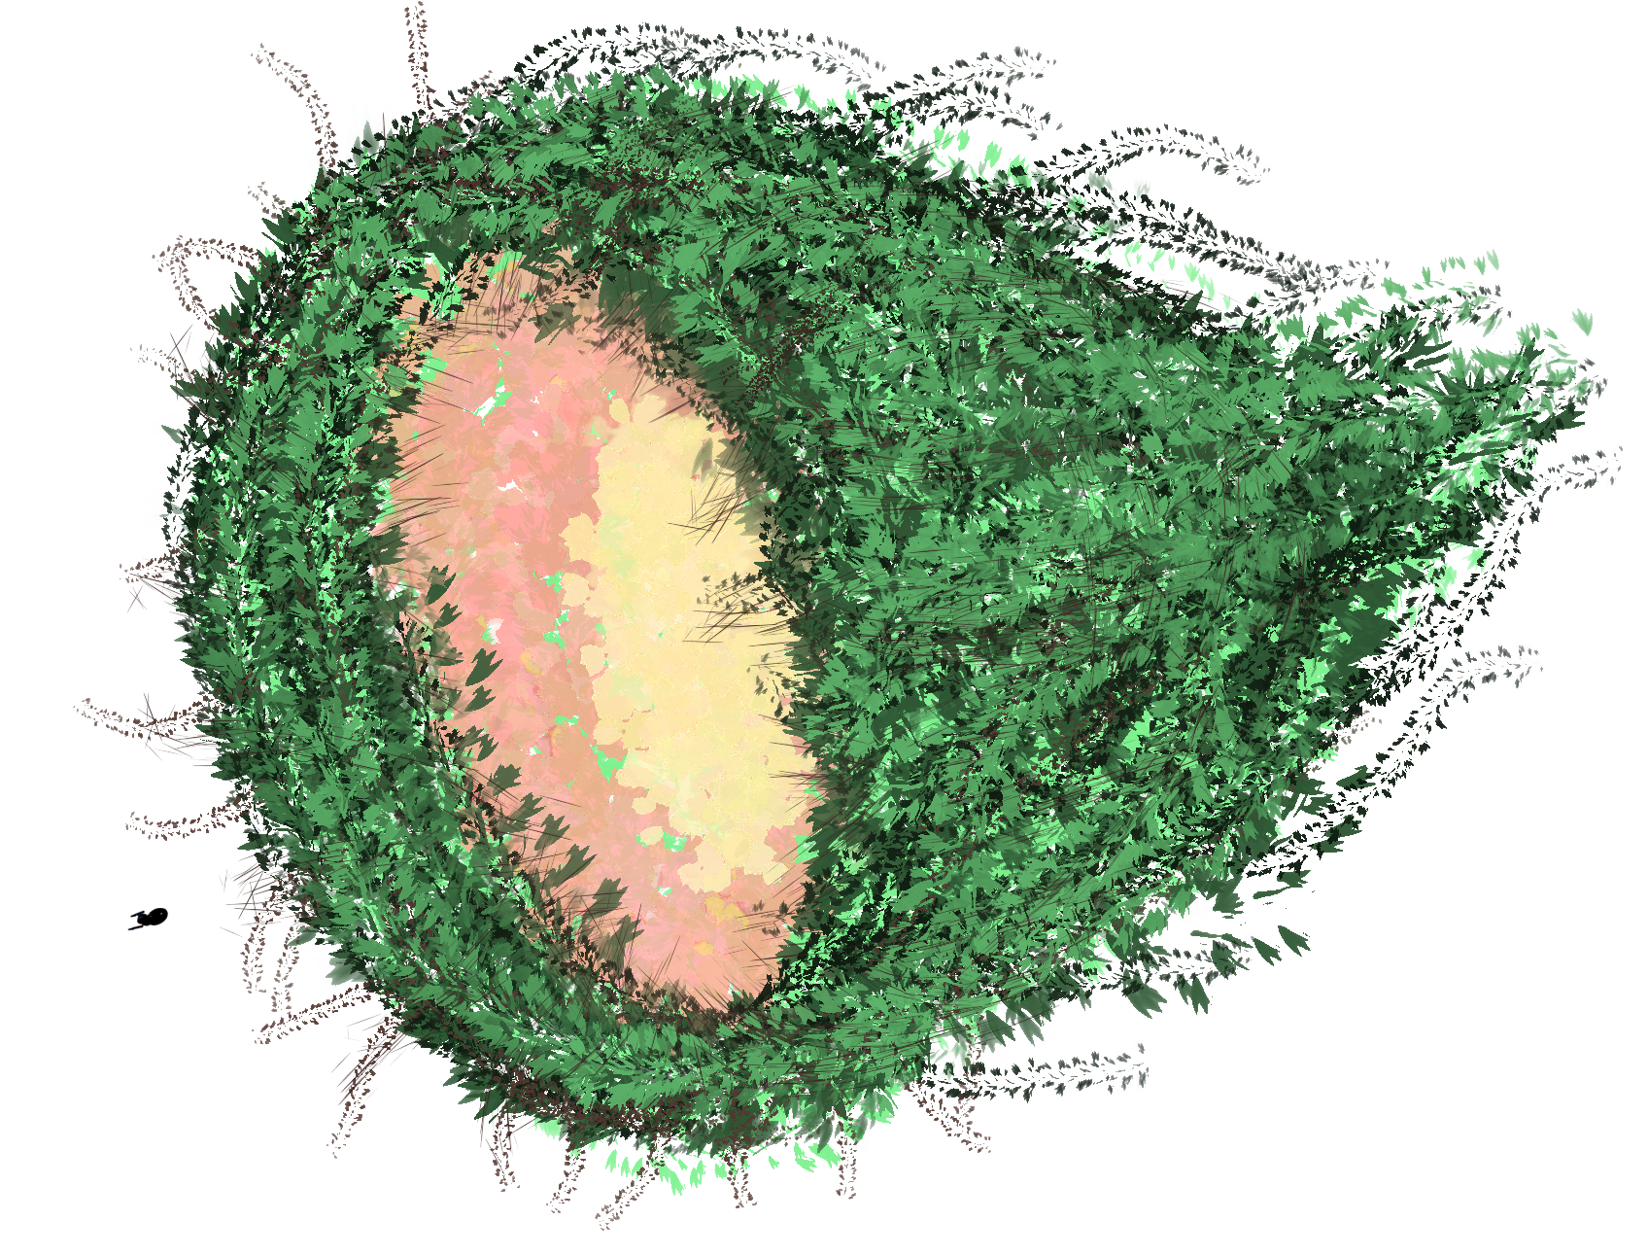
Dyson Vine Cult

Dyson Vine Seed
A gigantic plant making its way through star systems, devouring debris and planets on its way to find a sun to enclose itself around.

Traits: Cosmozoan Flora, Sentient, Red Giant-Sized
Scale: 100
Resistance: 10
Shields: 125

Systems
Comms - Engines 2 Structure 20
Computers - Sensors 1 Weapons 12

Departments
Command 5 Security 5 Science -
Conn - Engineering - Medicine 5

Special Rules:
- Regenerative Hull (see STA 2e Game Toolkit Booklet, page 29 )
- Point Defense System (see the 2e Core Rulebook, page 224)

Attacks:
- Photon Torpedoes: Torpedo, 5 Damage, Long Range, High Yield

Dyson Vine Cult Shuttle
Small, organic pods of plant matter carrying a few loyal worshipers to do its bidding.

Traits: Civilian, Small Craft
Crew: 1 to 4
Scale: 2 Shields: 10

Systems
Comms 6 Engines 9 Structure 7
Computers 6 Sensors 7 Weapons -

Departments
Command 1 Security 1 Science 1
Conn 2 Engineering 4 Medicine 1

Special Rules:
- Automatic Return (see the 2e Core Rulebook, page 220)

Attacks:
- Cutting Beam: Energy, 2 Damage, Close Range, Intense, Piercing

Roll Tables
Tables to roll for game masters and Captain’s Log players.

Species
1 | Other: humanoid but different Forehead
2-3 | Sarwai
4-5 | Chita-Delvan
6-7 | Chita-Gorvan
8-9 | Chlomorii
10-11 | Queenless Borg
12-13 | Tolan
14-15 | Aftanosian
16-17 | Dewai’i
18-19 | Other Quadrant Species
20 | Roll Again

Selecting a Mission Location
Region
1 | Quiet South | 10-11 | Borg Space
2-4 | Western SCIP | 12-14 | Unknown Northwest
5-7 | Eastern SCIP | 15-17 | Trianum Protectorate
8 | At/Near Starbase 418 | 18-19 | Unknown East
9-10 | Ahlen Church Territory | 20 | A Starless System

Additional Mission Theme Suggestions

Major Themes |  |  | Minor Themes
1-2 | Temporal War Battle / Scar |  | 1-11 | Roll on the Major Themes Table
3-4 | Historical Evidence of Ferengi |  | 12 | Study Pre-Warp Civilization
5-6 | Chlomorii Motherplant |  | 13 | Discover an untouched paradise
7-8 | Cultural Exchange with an SCIP world |  | 14 | Find a group of Sarwai in a remote place
9-10 | Ahlen Church Activities |  | 15 | Settle a new Federation colony
11-12 | Borg Attack or Aftermath |  | 16 | Other Quadrant Power’s Activities
13-15 | Dyson Vine seed’s wake of destruction |  | 17 | Bringing supplies to Expanse allies
16 | Dyson Vine Feeding on a Sun |  | 18 | Help Colonists from SCIP settlements
17-18 | Find a colony of Sarwai in a remote place |  | 19 | Bottle Episode on the Ship
19-20 | Roll on the Minor Themes Table |  | 20 | Back at Starbase 418

Adapting the Campaign
This section is here to provide guidance, but not concrete rules for adapting the story and ideas of this campaign guide for other historical periods and polities your group may be playing or prefer. From the fledgling United Earth’s first explorations, to the far-flung future of the 32nd century - from the glorious halls of Qo’noS to the machinations of an uncertain Romulan Free State - I hope you’ll be able to take the Sarell Expanse into your games.

22nd Century
Before the federation, Earth could be exploring a neighbor much closer to the borders than the campaign places the Expanse.
If your game is just after the Romulan War and the founding of the Federation, one could adjust Andoria shipyard’s involvement to reflect their new commitments to the federation.

Recommendations:

- Ships: The NX or Freedom Class are appropriate.
- Mission: The primary goal is simple exploration and survival. The loss of the colony is a deep crisis requiring a high-risk mission due to the difficulty of deep-space travel. Diplomatic overtures are less nuanced, often based on initial reaction and self-interest.
- Factions: The Federation is a new entity. Factions like the Sarellan Confederation are viewed with more caution and suspicion.
You shouldn’t introduce our Borg, but perhaps reflavor it as a different/new isolationist culture danger.

23rd Century
Captains’ Pike, Kirk, and Sulu have legendary careers in this century. It’s a bolder era full of cold wars and captains are often on missions to support the federation’s expanding borders. General Order One is well in place, particularly important as an alternative to the Klingon method of dominating pre-warp civilizations.

Recommendations:
- Ships: The Crossfield, Constitution, and Excelsior Class are the right hero ships to either use, or whose stats should re-flavor the Hugo and Pendragon classes, imagined as older designs.
- Mission: Trading partners, delivery of supplies between worlds, and finding out what happened to the lost colony are of much stronger weight in this century than the pure exploration and scientific exploration aspects.
- Tone: The Sarell Expanse Campaign leans harder into the optimism and weirdness of the Original, Animated, and Strange New Worlds’ series than the darker tones of early Discovery or the films.
- Factions: The Klingons should show up in more places to push forward the cold war atmosphere. Instead of the Queenless Borg, introduce other robot people. Perhaps they look just like humans!

29th Century
The 29th century focuses on temporal mechanics and safeguarding the timeline, often under the purview of the Department of Temporal Investigations (DTI).

Recommendations:
- Ships: Utilizing the Wells Class is a must, perhaps taking inspiration from ship stats found on the Continuing Mission website. To reflavor the look and feel of the ships from this book instead, you’ll need to rework the silhouettes to be even more futuristic and show off the “liquid-like” exterior material.
- Mission: The "lost colony" investigation might be reframed as a temporal anomaly. The crew is primarily tasked with maintaining the timeline, which could involve non-intervention or subtle course-correction of the Expanse’s history.
- Factions: The Queenless Borg should be far more integral to the story, as they claim a temporal incursion has altered the Borg to the probably-extinct Queen-led ones we knew. Or maybe the DTI believes them to be an echo or splinter group that must be neutralized to prevent a greater temporal catastrophe. The crew may be concerned with who planted the dyson vine and for what temporal purpose.
- Temporal Grenade is available now, Opportunity Cost of 1.

32nd Century
The post-Burn era of the Federation has a plethora of far-out technologies, isolated peoples and starships, and a renewed drive to reconnect. Make it about rekindling pre-existing relationships, or simply an opportunity to make new friends for the first time in centuries, now that the burn is over, to try and promote the rebuilding federation to the neighbors.

Recommendations:

- Ships: Use the ones from this guide, but imagine them with detached nacelles. The systems utilize programmable matter and other newly-developed tech that you’ll want to research by watching Discovery seasons 3+ and the Academy series.
- Mission: The Sarell Expanse is a chance for the Federation to prove its worth and stability to new, cautious neighbors. Diplomacy is crucial, as the Federation lacks the military or logistical power of previous centuries. The crew's main vessel might be the only one for light-years.
- Tone: A sense of fragility and hope. Every success is hard-won, and failure could mean the permanent dissolution of the region’s connection to the Federation. To add more challenge for the players, you could focus on Dilithium Shortages as an element to be mindful of in one mission or across the campaign, requiring barter and diplomacy.
- Temporal Grenades are now forbidden from use by the Temporal Accords and their use by any officer will result in reprimand or court-martial.

Klingon
A Klingon campaign replaces Starfleet’s exploratory mission with one of conquest, glory, or defense of the Empire’s borders. Their place on the edge of the Beta Quadrant makes the expanse their neighbors.

Recommendations:
- Ships: Any Klingon standard ship will do, from the D7 to the Vorcha and imagined newer models that can steal stats from the Pendragon and Ch’thoran classes.
- Mission: The Klingons are here to either claim the Expanse for the Empire, find a strategic advantage against a foe (Romulans, Federation), or confront reports of a Borg threat. The lost colony isn’t going to be as compelling here.
- Factions: Interaction with the Chita-Gorvan would be highly favorable, seeking alliances based on honor and combat prowess. The Sarellan Confederation is seen as weak or ripe for trade exploitation.
- Tone: Emphasis internal political rivalries between crew members or more likely, between ships led by different houses seeking glory and honor.

Romulan
A Romulan campaign centers on subterfuge, intelligence gathering, and securing a tactical advantage over rivals. Their long history surviving encounters with and stealing from the Borg might have pushed them into the region to collect and obtain even more technology.

Recommendations:
- Ships: a retrofitted D'deridex or Mogai Class would be the best choices. The free state probably hasn’t been able to invest in outright new designs, still reeling from the chaos of the supernova.
- Mission: The Romulan Free State is operating on the edge of the Expanse to establish a hidden base, secure resources, or disrupt Federation/Klingon interests. Manipulation in order to re-build the “free state” into a power as strong as the empire once was. There may be Tal Shiar agents whose main goal is to eliminate the remnant Borg, “Queenless” or not.
- Factions: The crew would likely engage in covert operations, avoiding direct contact, especially with the Starfleet forces active in the area. The Chita-Gorvan's natural xenophobia might be exploited for Romulan gain.
- Tone: High-stakes espionage, secrets-upon-secrets, and a whole region of new puppets to control. In other words, your typical Romulan campaign tone.

Ferengi
Whether you are playing as pre- or post-Federation membership (as begun in Lower Decks) Ferengi makes a difference, but these lovable scamps are sharp negotiators and traders regardless. May the Great Material Continuum guide you.

Recommendations:

- Ship: The D'Kora Class is the only one listed in the 2e Core Rulebook, but it’ll be very antiquated by the 25th century, so re-imagine one of the ships - like the Hugo as Fenergi designs. Or maybe you think the D’Kora will be in service for as long as Starfleet kept the Excelsior in service.
- Mission: The Sarell Expanse is a land of untapped markets and new suckers to make deals with. The objective is to secure lucrative trade agreements (or monopolies) and (if pre-Federation) exploit the locals. One might find the ancient writings of Ferungi visits via a wormhole of the past.
- Factions: Most interactions are economic. The crew is attempting to profit from the struggles between the Confederation, the Trianum, and the Ahlen Church.
The Trianum Protectorate is the most important political entity to contend with.
- Tone: Comedy, fast-talking, trade risk, and adherence to the Rules of Acquisition. The players are more likely to use Presence and Insight for bargaining and diplomacy.

- End Transmission -

see the 2e Game Toolkit, page 16
see the 2e Core Rulebook, page 212–215
see the 2e Core Rulebook, page 212–215
see the 2e Core Rulebook, page 212–215
see the 2e Game Toolkit, page 16
see the 2e Core Rulebook, page 212–215
see the 2e Game Toolkit, page 16
See earlier in this book
see the 2e Core Rulebook, page 212–215

